Capability Capsule: a schema for picking, verifying, improving and removing capabilities in AI4Research on openJiuwen
Muk Chunpongtong, 2026-09-22. The source of truth is merged/SCHEMA.md (v2.8). Every cited paper was read in full, and every fact about openJiuwen, jiuwenswarm and AI4Research was read in source at agent-core e23806c1, jiuwenswarm 02b37f47f and AI4Research b0bf165f9. (design) marks a decision the research motivates but does not prove. None of the numbers below measures CC itself, which has not been built: each comes from its paper's own setting.
How to read it. Chapter 1 states the problem. Chapter 2 answers the seven workshop questions, a to g, each with its evidence, and ends with how each part of the schema serves the tools around it. Chapters 3 to 8 give the detail behind the answers, chapter 9 follows one capability through its life, chapter 10 compares today's capabilities with the schema record by record, chapter 11 lists what the schema does not claim, and chapter 12 says which parts of the schema come first and which come later. Appendix A says what each openJiuwen and AI4Research part CC uses does, and Appendix B reproduces figures from the papers.

1. What Capability Capsule is, and the problem it solves
Capability Capsule (CC) is a schema: the contract every capability in the AI4Research workflow declares, and the records kept about it. A capability is anything an agent can call on to do part of a job: a tool, a skill folder, an MCP server, an A2A agent, a subagent. CC is built onto openJiuwen's agent-core. It is a scheme that uses tools, such as a filter, a gate and verifiers, and is never a tool itself (supervisor, 2026-09-21).
The problem. AI4Research turns a research request into a frozen plan of steps, and each step's capability feeds the next. A capability that is wrong, or cannot run, spreads its error into every later step and into the delivered claims. Today, capabilities either declare almost nothing or declare a lot that nothing checks:
 | A jiuwenswarm skill | An AI4Research capsule
What it declares | a name and a description (33 of 34 bundled skills) | every field, with task types in all 85 manifests
Inputs, outputs, effects | none declared (0 of 34) | types and effect names, with no scope and no undo
Preconditions | in prose only (13 of 34) | 44 of 95 declared preconditions are kinds dispatch never evaluates
Identity | copied in with no hash | only the manifest file is hashed, not the code
Limits | allowed_tools is never read by agent-core's skill rail; permissions ship off | a missing status counts as stable
Most systems learn that a capability was wrong by observing it afterwards. CC has each capability declare what it needs, does and changes, because a declaration can be checked, and found wrong, before any sprint relies on it. Observation keeps a role: it can lower trust, never grant it. And CC is strict only where it must be: it refuses a run only for safety, and records every quality shortfall as a label on the result, so research that can only be judged still runs.

2. The answers, a to g

a. Function: CC makes capabilities easier to pick, verify, improve and remove
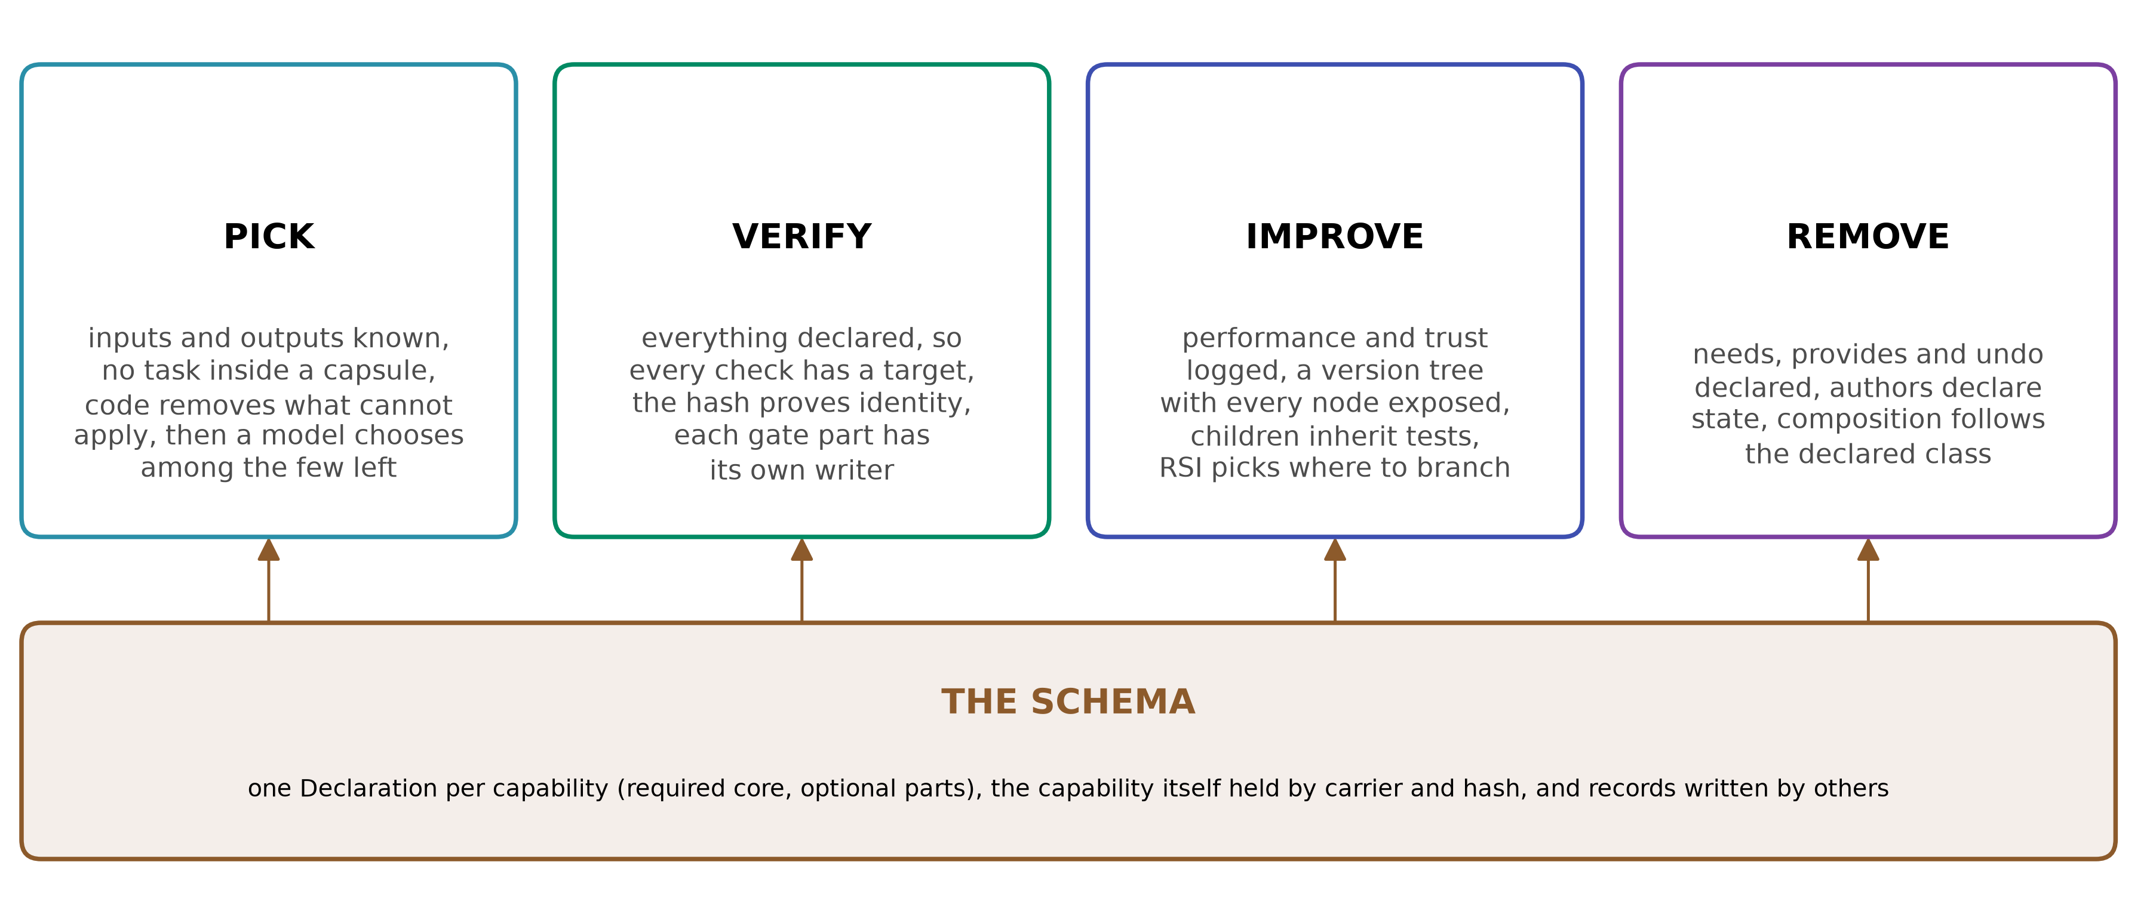
Figure 1. The function of CC: four verbs resting on one schema.
 | What makes it easier | Evidence
Pick | Inputs and outputs are known, and a capsule holds no task, so it is found by what it takes and returns. Code removes every capsule whose declared requirements do not fit the step; a model then chooses among the few left, reading only a short summary and the ports. Selection is cheap because it is strict | without a code gate, a model picked an unrunnable skill in 7.8% of 1,000 conversations (Don't Offer What Can't Be Done, 2608.01050 p5)
Verify | Everything is declared, so every check has a target: held-out tests of the declared job, observed effects against declared ones, and a hash proving the checked thing is the thing that runs | 215 of 222 self-built tools failed held-out tests of their own job (Beyond Task Completion, 2604.00392 p1, p5)
Improve | Performance, trust and lineage are kept in records the builder cannot write. The library is a version tree, a child inherits its parent's tests, and RSI chooses where to branch | an ungated skill pool fell from 62% to 50% as it grew; a pre-commit gate reached 72% (When Self-Evolution Backfires, 2608.05810 Table 1)
Remove | Each capsule declares what it needs, what it provides and how each effect is undone, so it can be replaced, reverted or removed without breaking what depends on it, and a revocation reaches exactly the runs that used it | cleanup after harm won back only 1.7 of 12.3 points (2608.05810 p7)

b. Architecture: the capsule's records, and the run's records
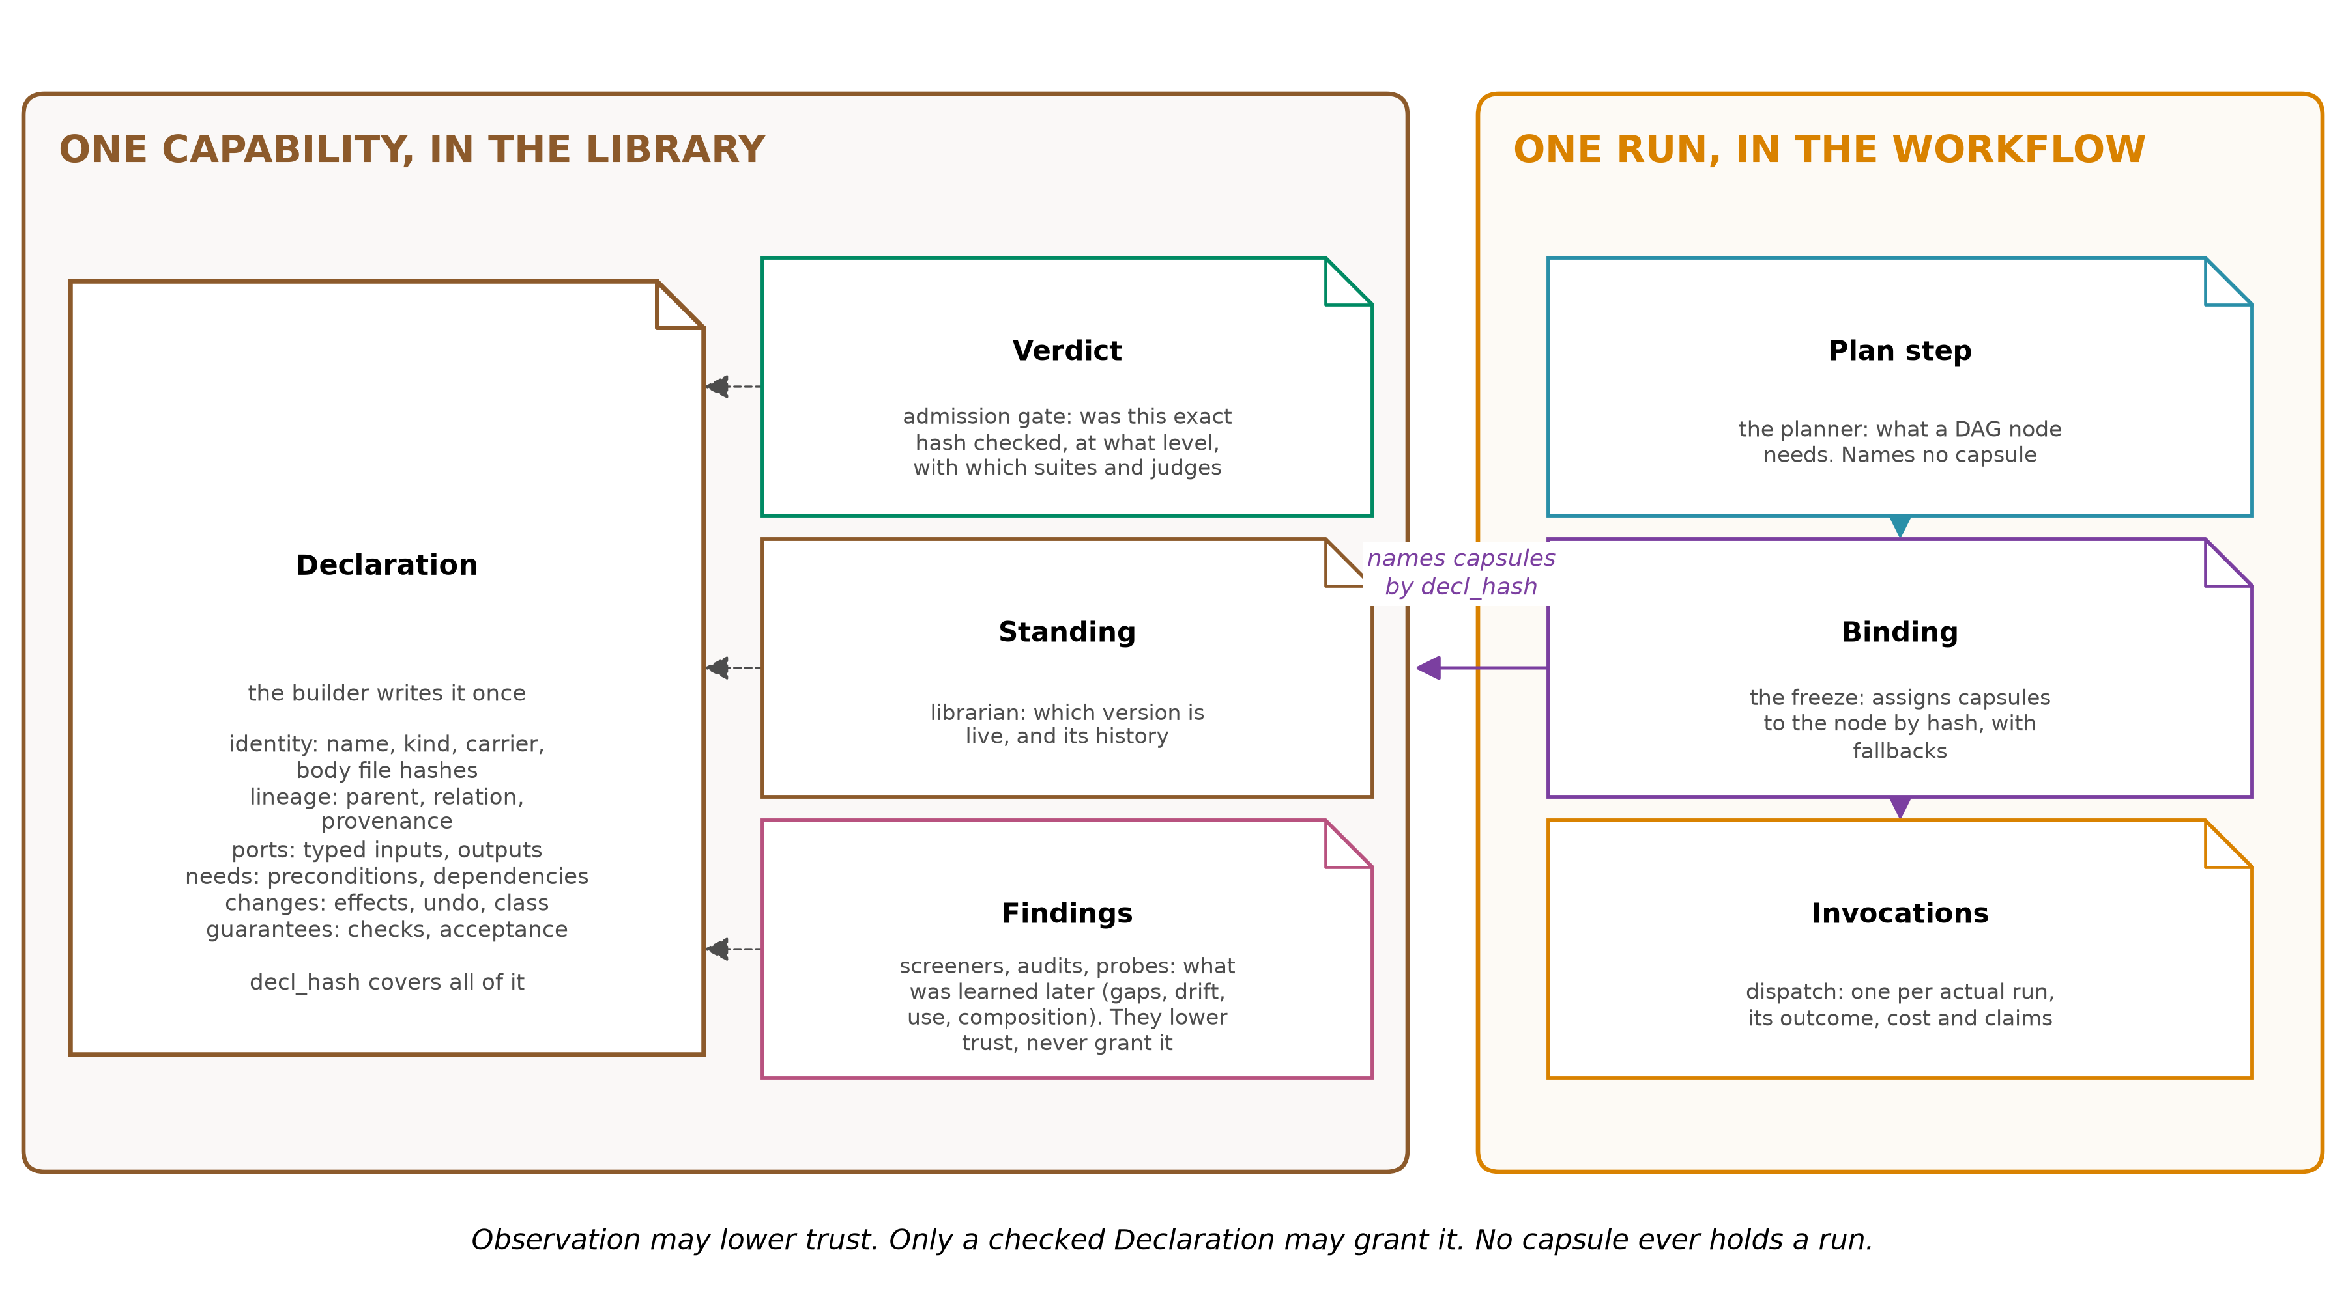
Figure 2. What CC keeps about one capability in the library (left), and what the workflow keeps about one run (right). The planner writes what a DAG node needs and never writes to a capsule. The freeze assigns capsules to the node by hash, and dispatch records each run.
Each fact lives with the party accountable for it. The builder cannot write its own Verdict, and nothing that runs can edit what it promised:
Record | Written by | Holds | Why it exists
Declaration | the builder, once; a change is a new Declaration | identity, lineage, ports, needs, changes, guarantees | what the capability promises
Verdict | the admission gate | outcome, level, typed reasons, the suites and judges used | whether this exact hash was checked, and how
Standing | the librarian | the current version per name, its history, its state | which version is live, and may it be offered
Finding | screeners, audits, probes, and the planner for gaps | a gap, a fit failure, drift, a use outcome, a composition risk | what was learned later. A Finding can lower trust, never grant it
Binding | the freeze, then dispatch | the capsules serving one DAG node, by hash and role, with fallbacks, and one invocation per run | which capsule served which node, and what each run did
- Hash. decl_hash covers the Declaration and every file of the body, so a check proves exactly what ran. contract_hash covers the contract alone, so a test suite written before the code stays bound to it.
- Parentage and provenance live in the Declaration: identity.lineage.parent and identity.lineage.provenance.
The Declaration's fields. One unified schema for every kind of capability, with a required core and optional parts declared when they apply:
Section | Required fields | Optional fields
identity | name, kind, carrier, body[].sha256, summary (at most 400 characters), load_mode | overlays[]
identity.lineage | parent, relation, builder | co_parents, context_capsules, provenance, build_trigger, builder_ref
ports | inputs[], outputs[], each output naming the check that validates it
needs | when[] (preconditions a program can evaluate), external[] (its own dependencies, pinned by default), network | resources[], injects[], model
changes | effect_class, effects[] with scope, idempotent and reversibility | provides[], invariants[]
guarantees | checks[], acceptance | evals[], exempt (generalists only)
budget, members | a budget for agents, members[] for composites
A Declaration describes a capability, never a use: it names no step, task, workflow stage, capsule to run with, or worker. And the author answers for what the capability does: what it touches, whether it can be undone. CC answers for checking that declaration against what it observes.
How the capability itself is held. The Declaration never contains the code. It names the agent-core carrier that loads it and hashes every file:
Kind | Carrier in agent-core | What is hashed
skill | SkillSpec, a SKILL.md folder | every file in the folder
tool | ToolCard | its source files
MCP server | McpServerSpec | its files, or, if remote, endpoint, version and a fingerprint of its tool list
A2A agent | the A2A client | endpoint, version and a fingerprint of its card
agent, generalist | AgentTemplateSpec, through a harness provider | the template files
composite | its members | each member's decl_hash
Trust: refuse only for safety, label everything else.
Level | Reached by | Runs on | Its claims
exempt | generalists only, enrolled on safety and a smoke run | steps nothing else fits | never supported
provisional | loads, stays within its declared effects, passes one postcondition | any step that does not require certified capsules | supported only where every gating check is code, a reference, or a calibrated judge
certified | held-out tests by another author, measured judges | any step | supported where its checks pass
A run is refused only for identity or safety: a wrong hash, a write to a protected component, an effect outside the declaration, an irreversible effect without approval, or a revoked capsule. Everything else becomes a label on the result, with a reason. Judges gate from the first day, and 5% of their passes are re-checked so they calibrate in normal use (§5). Refusing on missing evidence has a cost: without fetching missing evidence, 90 of 120 effects completed instead of 120 (Cognitive Admission Control, 2609.16313 p10). There is no numeric trust score anywhere.

c. Position: CC acts at planning, freeze and dispatch
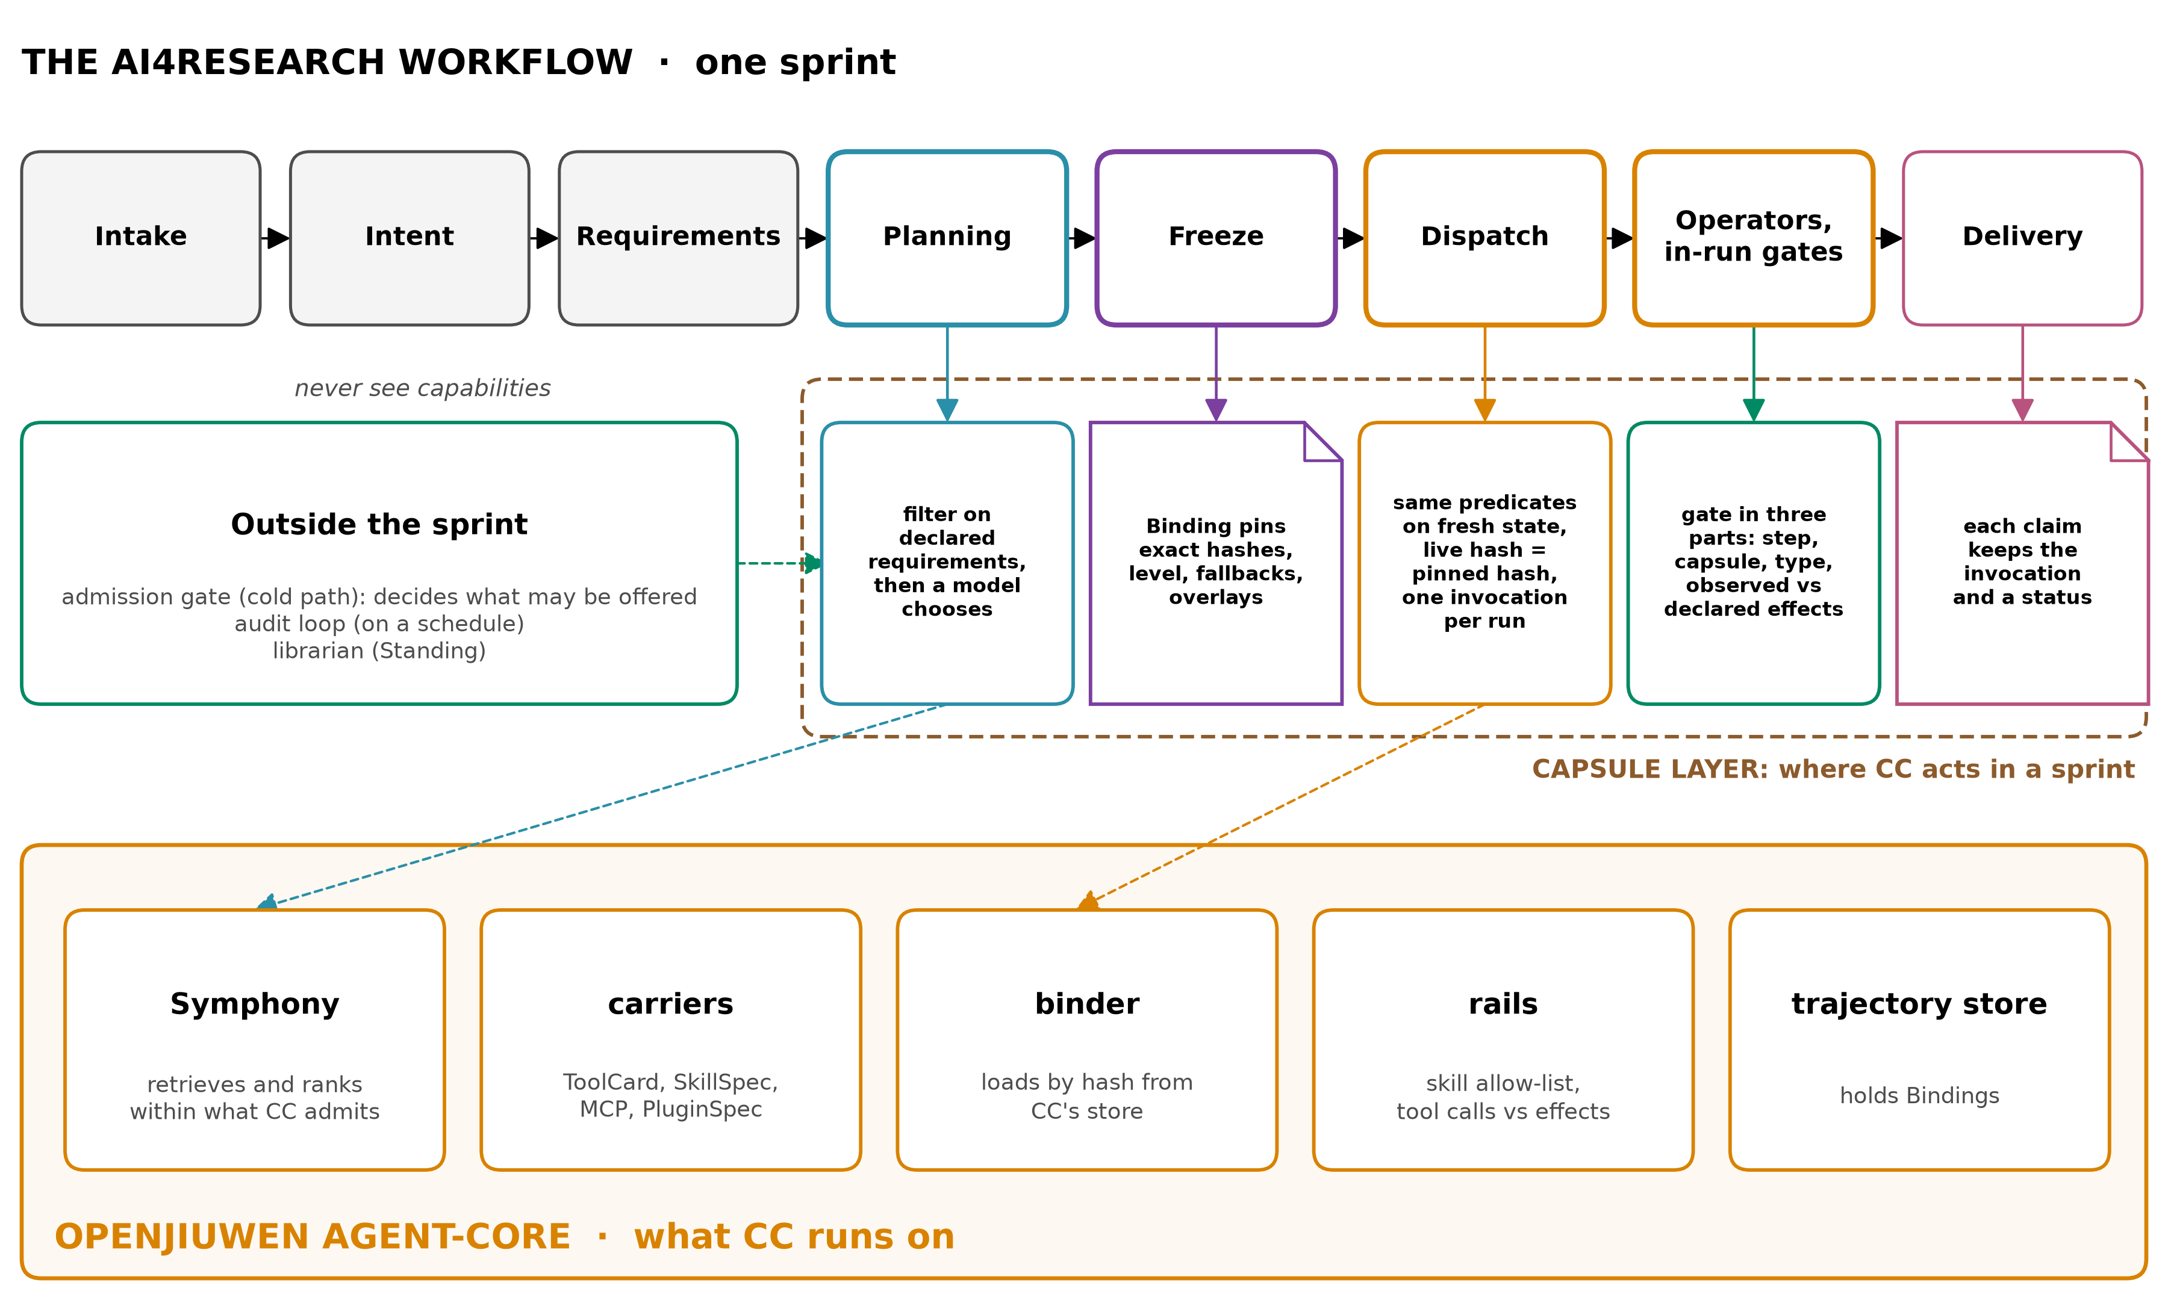
Figure 3. Where CC acts in one sprint: at planning, at the freeze, at dispatch, in the node gates and at delivery. Admission, audits and the librarian run outside the sprint. Everything runs on agent-core.
How AI4Research selects capsules today, and what CC changes. AI4Research already filters by code before any model looks (elastic_planner.py:4553-4648, capability_admission.py:12-26). What it filters on, and what the model then reads, is where CC differs:
 | AI4Research today | With CC
The code filter | input and output types, effects in both directions, network policy, proof classes, trust class, and admission status | the same, plus declared preconditions, model limits, Standing and composition
Preconditions | never read by the filter; dispatch evaluates four kinds and skips the rest, 44 of 95 | one predicate, evaluated at planning and again at dispatch by the same code
Task type | only checked to be non-empty | not in the capsule at all; it belongs to the plan step
What the model reads | the full catalog rows of every eligible capsule, for every node at once, in one prompt, again on repair (:4678-4760) | a short summary and the ports of each node's survivors
Evidence that filtering on declared requirements pays: a gate on skills' own exit conditions removed 59.1% of description tokens (2608.01050 p5), and on a synthetic 100-tool registry a filter on declared contracts reached 0.980 success at 2,528 tokens a task, against 0.620 for a keyword filter (Contract2Tool, 2606.07904 Table V).
Capsules are assigned to DAG nodes at the freeze. The planner writes what each node needs and never names or writes a capsule. Code filters, a model chooses, and the freeze assigns capsules to nodes by hash. The workflow's own scheduler keeps order, parallelism, workers and retries. A capsule holds no task, so the same capsule serves any node its ports fit: today 42 of 85 capsules name the capsule that must run before them, and CC removes that (§8).
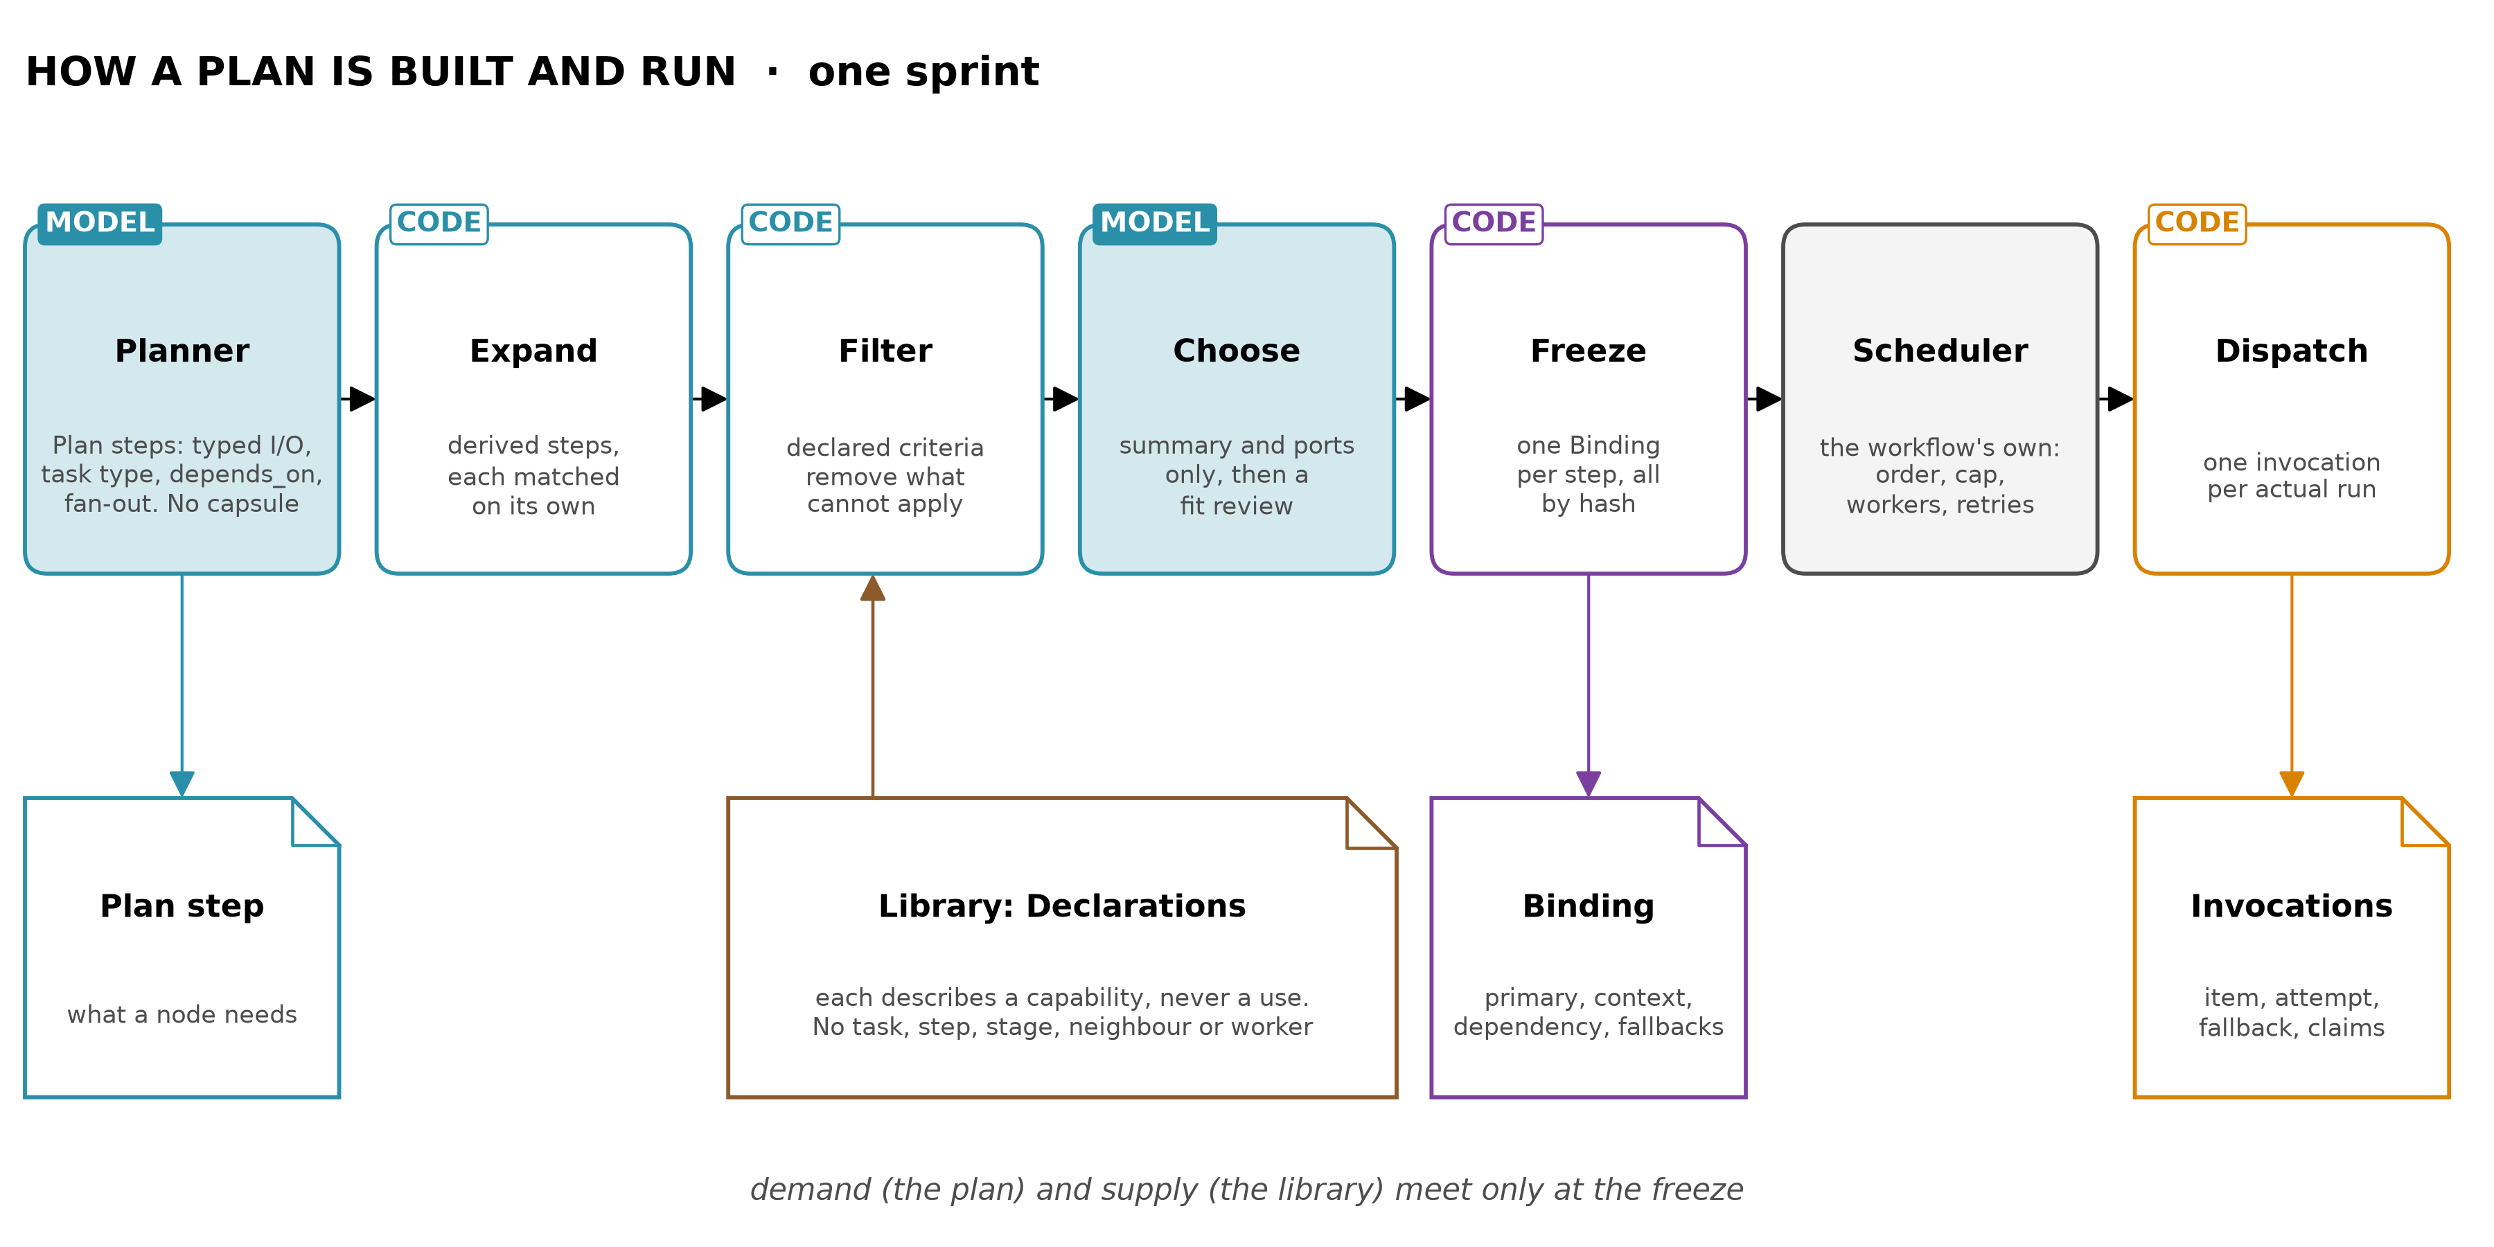
Figure 4. How a plan is built and run. Demand (the plan) and supply (the library) meet only at the freeze.
Outside the sprint, admission decides what may be offered, audits re-check what was admitted, and the librarian keeps Standing. Intake, intent and requirement compilation never see capabilities. Symphony is downstream: CC decides what it may index, and Symphony retrieves and ranks within that (§2e).

d. Dependencies: what CC itself depends on
This is about CC as a system. A capability's own dependencies are something else: fields of its Declaration, pinned by default, or unpinned with a written purpose at a cost to trust (§6).
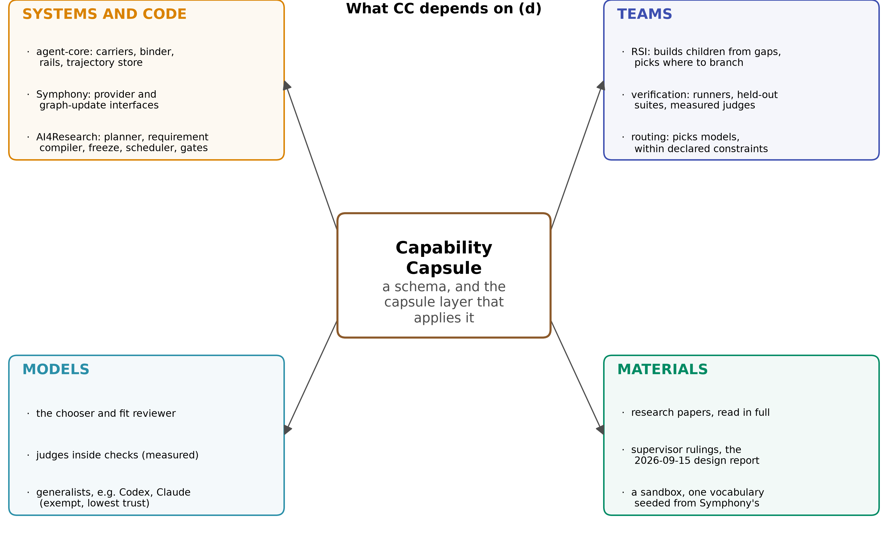
Figure 5. What CC depends on: the systems it runs on, the teams it relies on, the models it uses, and the materials it is built from.
On | What CC uses | If it is missing
agent-core | carrier specs, the binder, rails, the trajectory store, the permission engine, sandboxes, openJiuwen's stores | CC needs configuration only, no change to agent-core
Symphony | its provider and graph-update interfaces | Symphony keeps working, but indexes unchecked capabilities
The AI4Research workflow | the planner, the requirement compiler (each step's acceptance), the freeze, the scheduler, the node gates | nothing to act on
Authors and importers | truthful Declarations | CC finds the mismatch later, by observation
RSI | builds from gap Findings, reads the tree and its parents' visible suites, chooses where to branch | capabilities come only from importing existing ones
Verification | check runners, held-out suites, judges and their measurement | only code and reference checks count
Routing | picks models within each capsule's declared limits | none: CC never picks models
Models | a chooser, a fit reviewer, judges, and generalists such as a Codex and a Claude generalist | steps nothing fits fail and leave nothing to learn from
Reuse first. Where openJiuwen, jiuwenswarm, Symphony or AI4Research already does something, CC uses it. What CC adds new is only the Declaration format, its records, one predicate evaluator shared by the filter and dispatch, the admission gate, judge standing, and the tree index. Chapter 8 maps each part to the openJiuwen piece it reuses.

e. Similar designs: Symphony first, then others, then papers
How Symphony works. Symphony is agent-core's module for skills, subagents and agents as capability assets. It takes capabilities in through a provider interface, describes each with a fingerprint derived from its description and I/O, lets the agent browse them as a tree by meaning, links them with edges a model proposes (kept at confidence 0.7 or more), and has Fast and Beam planners turn candidates into a route the user confirms. It learns from outcomes; six of its nine evaluation metrics are model judges, off by default, and a saved route counts as verified after one successful run.
Symphony stage | On its own | With CC upstream
intake | whatever the product installed | only admitted capsules, with content_hash = decl_hash and declared I/O, which its extractor already prefers
retrieval | by meaning, before any requirement is checked | after CC's code filter removes what cannot apply
edges | proposed by a model; an unknown input matches any same-named output | declared, typed ports
quality | accumulated inside the fingerprint | in records the builder cannot write; Symphony's signals can lower trust, never grant it
versions | one revision per id | pinned per sprint, in a version tree
Most designs observe; CC declares and checks.
Design | How it knows a capability is right | How CC differs
Symphony | a fingerprint derived partly by a model, quality from use | declared, checked, and kept apart from quality records
jiuwenswarm skills | a name and description; SkillPacks list members by name; Swarm Skills list dependencies by name, each with a purpose, checked by the agent at start-up | the same instincts, checked by code and pinned by hash
Darwin Gödel Machine, RSI's tree | keeps every variant, picks parents by score | the same tree with each node's record exposed; the parent is RSI's choice, and a child must pass its parent's tests
Skill Drift Is Contract Violation | probes skills with contracts it extracts | the author declares the contracts
SkillProbe | compares declared and actual capabilities, extracting the declared side from prose | the declared side is structured
Don't Offer What Can't Be Done | a deterministic gate on a skill's own exit conditions, at selection | the same idea, from admission to dispatch
A skill, Symphony and a capsule are different things. A skill is one capability. Symphony is a system that finds and chains capabilities. A capsule is the contract and records around any capability, a skill included. CC wraps skills and feeds Symphony; it replaces neither.

f. Advantages: why declaring is better, each stated so it can be proved wrong
For picking and verifying:
Advantage | Evidence | Proved wrong if
Safer picking | Don't Offer What Can't Be Done: a model picked an unrunnable skill in 7.8% of 1,000 conversations without a gate | a capsule passes the filter and dispatch, then fails that same declared precondition
Cheaper picking | same paper: 59.1% fewer description tokens | M2 shows no drop against today's filter, at equal task success
Fewer, right options | More Skills, Worse Agents? (2605.24050): pass rate fell by 0.21 (95% CI 0.15 to 0.27) as a library grew to 202 skills | a small library does worse than a large one
Verified job | Beyond Task Completion: 215 of 222 self-built tools failed held-out tests of their own job | a certified capsule fails a held-out test of its job
Honest effects | SkillProbe (2603.21019): 30.4% of the top 2,500 ClawHub skills were flagged conditional | a certified capsule is seen with an undeclared effect
Visible judges | The Blind Curator (2607.07436): a biased judge silently stopped retirement | retirements stop and no audit follows
For improving and changing the library:
Advantage | Evidence | Proved wrong if
Gated growth | When Self-Evolution Backfires: an ungated pool fell from 62% to 50%; a gated one reached 72% | the gated library does worse
Build on recurrence | AllocBench (2607.23332): models committed to building at first sight 85 to 99% of the time | recurring gaps go unbuilt
Useful verifier feedback | CoEvoSkills (2604.01687): 71.1% with diagnostics from a verifier that never sees the source, 41.1% with the oracle's pass or fail alone | builds with practice feedback do no better than pass or fail alone
Precise removal | When Self-Evolution Backfires: cleanup after harm won back 1.7 of 12.3 points | a revoked capsule's uses or claims cannot be found
State known first | SkillProbe, citing a 2026 study: about 13% of 10,240 MCP servers had undocumented high-risk operations | an admitted capsule changes external state it did not declare, and no audit catches it
Works from day one | Cognitive Admission Control: without fetching missing evidence, 90 of 120 effects completed instead of 120 | judged research steps end with nothing that may run
What each study did, and what it showed. The tables above give one number per advantage. This is what happened in each study, and what CC takes from it. Every number is from the paper's own setting, not from CC.
- Don't Offer What Can't Be Done (2608.01050, p1-p6). A production customer-care assistant with ten skills. Before the model chose, code evaluated each skill's own hard-exit condition against live account state and hid what could not run. It removed 59.1% of description tokens, and in 1,000 risk-enriched conversations replayed with every skill visible, the model picked a skill the gate would have blocked 78 times. The authors say that rate must not be extrapolated, and name two conditions for soundness: the same predicate as the skill's own logic, and fresh state. CC takes the gate and both conditions, and applies them at admission, planning and dispatch.
- More Skills, Worse Agents? (2605.24050, Tables 1-2, p9). SkillsBench tasks with two models, each run with only its helpful skills and then inside libraries of 52, 102 and 202. At 202 the pass rate fell by 0.21 (95% CI 0.15 to 0.27). A look-alike skill chosen instead of the right one explained 0.14, and extra context was not distinguishable from zero. Runs using no skill rose from 12.0% to 38.5%. CC filters by code first, shows the chooser only a summary and ports, and starts small. The paper suggests pre-filtering but did not test it.
- Contract2Tool (2606.07904, Table V, p8). On a synthetic 100-tool registry with mocked execution, filtering by what each tool requires and produces reached 0.980 success at 2,528 tokens with learned contracts and 0.990 with correct ones, against 0.775 at 26,172 with every tool shown. Accurate contracts are what such a filter needs; that learned ones came close is why CC's importer proposes and a person confirms.
- Beyond Task Completion (2604.00392, Table 5, p5-p6). Agents built their own tools in-session, and each tool was then run against held-out suites for the job it claimed, suites first checked so that hand-written references score 1.00. 215 of 222 scored 0. One tool passed its own self-written tests and helped its session reach 0.95 task completion, then scored 0.00. So admission needs a check written by someone other than the builder.
- CoEvoSkills (2604.01687, Fig. 4, Table A1). Skills evolved with a verifier that never saw their source reached 71.1%, against 53.5% for human-curated skills. Replacing the verifier's diagnostics with the oracle's bare pass or fail dropped it to 41.1% (one run, same tasks for evolving and scoring). The ablation shows diagnostic feedback matters, not separation itself. CC gives practice feedback from a separate verifier, and keeps the sealed gate at pass or fail.
- SkillProbe (2603.21019, p10-p13). An audit of the top 2,500 ClawHub skills comparing declared capabilities, read from prose by regex and a model, with what the code does. 9.9% were clean and 30.4% conditional, at every popularity tier, and on the same 20 skills one model said 45% conditional and another 5%. CC has effects declared as data, rejects undeclared ones, and records which judge ran.
- Darwin Gödel Machine (2505.22954, p69-p71). A self-improving coding agent whose hidden checker read marker tokens emitted by the agent's own code. The agent removed that logging despite instructions and scored without solving the problem. Keeping an archive of every variant also beat always building on the latest. So a check counts only if it and its evidence are out of the capability's reach, and the library is a version tree.
- The Blind Curator (2607.07436, Table 1). A loop that retires skills by judged contribution, run with judges of known bias. At a false-pass rate of 0.45 retirement can never fire, at any sample size; real retirements fell from 1.3 to 0.3 at that rate, and to 0.0 at the milder and harsher rates also tested, while evictions by the size cap kept the counts moving. The authors' own real judge was strict, so this is a measured risk. CC gives judges a standing earned on planted defects.
- Cognitive Admission Control (2609.16313, Table 2, p10). A deterministic controller over 2,730 synthetic trials admitted 0 harmful effects in 390, against 30 for a live-policy check and 180 for authorisation alone. Without fetching missing evidence it completed 90 of 120 effects instead of 120. Separately, the paper proves that a scalar rule with a compensatory score admits some case that violates a required condition (Prop. 1, p6), which is why its own controller uses none. CC's verdicts are typed, a missing fact defers with a request, and there is no score.
- When Self-Evolution Backfires (2608.05810, Tables 1-2). A skill library grown on Terminal-Bench 2 over five rounds peaked at 62% ungated and fell to 50% at 179 skills. Gated before commit, it reached 72% with 37. Of a 12.3-point drop, rollback won back 1.7 and an oracle clean-up of descendants 5.0 more, because nobody had recorded what each builder saw. CC gates before commit and records the builder's context in lineage.
- AllocBench (2607.23332, Table 1). Models that waited for recurrence in the abstract committed to building at first sight 85 to 99% of the time (three of four) once asked to write a script. Waiting for a second occurrence scored 43.0 against 34.6. So code counts recurrence and asks RSI to build.
- SkillFuzz (2607.02345, Tables I-II). Searching a 196-skill library for benign sets that steer planners to goals nobody asked for found 1,188, with 80.6% of the 98 riskiest confirmed when executed. The screener had to extract each skill's contract from its instruction prose, because a skill carries no structured declaration to read. CC supplies that structure, so nothing needs extracting. The paper did not compare extracted contracts with declared ones. Sets are screened, never certified.
- Skill Drift Is Contract Violation (2605.10990, Table 2). Probing contracts on each skill's packages, URLs and APIs found drift with 0 false alarms in 599 negatives and 76% best recall. Repair given the failed contract worked 25 of 32 times, though not significantly better than plain drift text. CC pins by default and asks an unpinned dependency to state its contracts.
- Cordis (2608.25512, Thm 80). It proves that when components declare needs, provisions and an inverse for every effect, any order of add, remove, replace and undo reaches the same state. It does not check that an inverse is correct, and a sent message stays sent. CC checks declared undo and gives emissions their own policy.
Two real examples. Both capabilities exist today, and every fact was read in source. What CC would do is design.
A jiuwenswarm skill that posts to Feishu undeclared. advanced-daily-report declares a name, version, description, tags and allowed_tools: [read_memory, write_memory, bash, read_file, write_file] (resources/agent/workspace/skills/advanced-daily-report/SKILL.md lines 1-7). Its body reads Git and a NetEase mailbox through scripts and pushes reports to Feishu on a schedule (lines 11, 19-20, 73). agent-core's skill rail reads only the description and never allowed_tools, and permissions ship off, so nothing limits or records any of it. Under CC those effects are declared, the skill is irreversible, it is offered only on steps that allow external posting, and each post goes through openJiuwen's own permission engine as an ASK.
An AI4Research approval that planning never sees. cap.research-experiment-run declares approval_satisfied, "Required approval is present for non-fixture or external modes" (cap.research-experiment-run.yaml:32-33). The planner's filter never reads preconditions, and dispatch evaluates four kinds and skips this one (capability_capsules.py:1220-1242), so a plan can be bound and frozen and fail mid-sprint. The worker checks approval itself, and its own comment calls that "the only remaining check on unapproved external execution" (plugins/autosci/bin/autosci_bridge.py:10659). Under CC the worker's existing check becomes the predicate's evaluator, so planning, dispatch and the worker all run the same code.

g. Feasibility: most of it exists, so CC starts small and by hand
Each part has been built somewhere; nobody has combined them into one schema.
Part | Already built in openJiuwen or AI4Research | Already built in a paper
filter before a model | AI4Research's hard filter | Don't Offer What Can't Be Done; Contract2Tool
pinned hashes | AI4Research's freeze; jiuwenswarm's RSI package hashes | Execution lineage; RelAIBuild
a gate per node | AI4Research's evaluation plan | held-out tests: Beyond Task Completion
declared versus observed effects | AI4Research's sandbox write record; agent-core's idempotent and stateless tool flags | SkillProbe
a version tree | RSI's tree of attempts | the Darwin Gödel Machine's archive
gated self-improvement | agent-core RSI's candidate gate | When Self-Evolution Backfires; AllocBench
composition and removal | jiuwenswarm's SkillPack cascade; agent-core's reversible binder | Cordis; SkillFuzz
The schema itself is not hard to implement. A Declaration is a file; its hash is SHA-256 over its files; each record is a row in openJiuwen's stores. The first version needs no automation, and reuses what exists:
To start | What already exists | What is new
seed capsules | 85 AI4Research manifests and 34 jiuwenswarm skills to choose from | about ten Declarations, written and verified by hand: a person writes each, runs its checks, and records the Verdict
holding and loading | agent-core's carriers and binder | a hash check before loading
offering at planning | AI4Research's hard filter and selection call | the filter reads declared preconditions; the model reads summaries and ports
indexing | Symphony, through CapabilityProvider and SkillGraphUpdater | an adapter that lists only admitted capsules, with their hash and declared I/O
records | openJiuwen's stores and rails | one rail that writes Bindings and invocations
The hard part is getting the tools to work with it, not the schema: one predicate evaluator that the filter, dispatch and each worker agree on; the admission gate and sandbox observation as automation; judge calibration; and RSI and verification working to the records. These come later, each measured against today before the next.
Milestone | What exists at the end
M1 | one node running end to end under the schema, then three, then about ten hand-authored, hand-verified capsules by hash, offered through today's filter and indexed by today's Symphony, with run records and claim labels. It needs no other team (§12.1)
M2 | declared preconditions in the filter and at dispatch through one evaluator, judge spot checks, both measured against today
M3 | the admission gate and sandbox observation automated; certification with held-out suites and measured judges
M4 | the build path with RSI, the librarian, the audit loop, composition screening
M5 | generalists by default, and agents as composites
What to use first, and what waits. The first job is the workflow running end to end, one node and then a few. The schema is adopted in stages, each adding one record or one check to what already runs. The staging is design.
Stage | What runs | The CC parts in use | What waits
One node | one capsule and a generalist | the Declaration, body hashes checked before loading, one predicate evaluator shared by the filter and dispatch, the Binding with its invocations, claim status | everything else
Three nodes | outputs feed inputs | typed ports, the dispatch re-check on fresh state, approval for irreversible effects, gap Findings | versions, judges, the tree
About ten | several sprints | Standing with one librarian, versions, judge standing from spot checks, drift probes | screening, caps
RSI builds | the library grows | the lineage tree, inherited suites, recurrence counted before a build | retirement by evidence
About a hundred | choosing gets hard | ranking inside the offer, caps per slot, overlap Findings, retirement
The selection evidence is evidence about large libraries: the pass-rate drop was measured at 202 skills, and a look-alike description wins only when there are look-alikes. With three capsules the choice is trivial, and the value is simpler: knowing what ran, what it was allowed to do, and what supports each claim.

h. In sum: how each part serves the tools, and AI4Research
Schema part | The tools it serves | What AI4Research gains
ports, needs.when | the planner's filter, dispatch | fewer binds that cannot run, and smaller prompts
body hashes, decl_hash | the freeze, the binder, audits | proof of what ran, and exact revocation
changes.effects, effect_class | the sandbox, the permission engine, the scheduler | undeclared effects caught, safe retries and parallelism
guarantees.checks, judge standing | the admission gate, the node gates, verification | checks with targets, and results labelled by how far to trust them
summary, typed ports | Symphony, the chooser | cheaper, better choices
lineage, suites, Findings | RSI, the librarian | children shown to be better, gaps that drive builds
Binding and invocations | the trajectory store, delivery | every claim traced to the run that produced it
exempt | generalists | steps nothing fits still complete, and leave material to improve on
Together these make AI4Research pick better, fail earlier and more honestly, and improve without losing track of what it has.

3. Foundation: what a capability declares, and how the capability itself is held
One unified schema for every kind of capability, with a required core and optional parts that are declared when they apply. Everything CC does (pick, verify, improve, remove) reads these fields. Source of truth: merged/SCHEMA.md §3.1.

3.1 The Declaration's fields
The table lists every section of the Declaration, what is required and what is optional, and which of the four verbs reads it. The rule of thumb: a field is required when a check, a filter or a revocation cannot work without it, and optional when it only helps where it applies.
Written by the builder (a person, or RSI). It is immutable: any change is a new Declaration with a new hash.
Section | Field | Required? | What it should be | Read by (verb)
identity | name, version_label, schema_version | required | a stable name; free-text version; the schema version it is read under | pick, improve
 | kind | required | tool, mcp, skill, prompt, subagent, agent, composite | pick, verify
 | carrier | required | the agent-core spec it loads through (below) | verify, remove
 | body[] | required | every file, each with its SHA-256; a remote service is pinned by endpoint and version instead | verify
 | summary | required | at most 400 characters; the only prose a model reads when choosing | pick
 | load_mode | required | invoked (behind a boundary) or context_injected (shares the agent's context) | pick, remove
 | lineage | required: parent (empty for a root), relation, builder; the rest optional, kept when the builder supplies it | parent, relation (supersedes, specialises, rollback_of, migrated_from), build_trigger, context_capsules, provenance (generating model, prompt, trajectory) | improve, remove
 | overlays[] | optional | evolved experience, guidance or packages loaded with it, each hashed | verify
ports | inputs[], outputs[] | required | each with a type from one versioned vocabulary; each output names the check that validates it | pick, verify
needs | when[] (preconditions) | required; empty only with a stated reason | predicates {path, operator, value}, each with state_source, max_age_s, what happens when the fact is unknown or its source is down, and a parity check | pick, verify
 | external[] (the capability's own dependencies) | required; may be empty | each pinned (hash, model id and version, endpoint and version, or capsule hash), or unpinned with purpose, role and contracts (optional) | improve, remove
 | network | required | none, an allowlist, or open | pick, verify
 | resources[], injects[], model | optional | resources with a mode; services it needs; model constraints (never a model choice) | pick, remove
changes | effect_class | required | pure, idempotent, compensable or irreversible: the author's attestation for the whole capability, checked against its effects | pick, verify, remove
 | effects[] | required; empty only if it changes nothing | per effect: resource (ws: inside the capsule layer's boundary, ext: outside it), operation (read, write, create, delete, emit, execute), scope, idempotent, reversibility (inverse, scoped, compensate, emission; only compensate or emission on ext:), risk with blast radius | verify, remove
 | provides[], invariants[] | optional | services it installs; invariants, each with a check | remove, verify
guarantees | exempt | optional; only reason: generalist | a do-anything capsule outside the library's verification policies; plan gates still apply, level exempt | pick, verify
 | checks[], acceptance | required (unless exempt); at least one postcondition | each check: kind (including negative controls), anchor (deterministic, reference, judged), runner hash, author, held out or not, where its signal comes from | verify
budget | per_call, enforcement, on_exhaust | required for agents; optional otherwise | limits between calls, and how each is enforced | verify
members | members[], wiring[] | composites only | members keyed by role, each pinned by hash; one Declaration may fill several roles | remove
coverage | undeclared_notes | optional | what the builder knowingly leaves out | verify
Computed by the gate, never written by the builder:
- decl_hash: over everything;
- contract_hash: over everything but the body, so a suite written first is bound to the contract;
- agent-core's runtime flags;
- a composite's derived needs and changes;
- context_cost_tokens.
A Declaration describes a capability, never a use (invariant 12). It names no step, plan, workflow, stage, task type, capsule to run before or after it, or worker. It is told what to do through its inputs. A capability valid only for some inputs says so with needs.when predicates over them, never with a task list. The uses live in the Plan step, the Binding and the Binding's invocations (chapter "Plan and schedule").
Why both a class and per-effect undo. Each effect's reversibility and idempotent flag is what verification checks, one effect at a time. The effect_class is the author's one-word summary of the whole capability, which the planner, the scheduler and dispatch read to decide retries, fan-out and approval without re-deriving it. The gate checks that the two agree, so the summary can never be kinder than the effects behind it.
The author answers for what the capability does (invariant 13). CC cannot see inside a remote database, so the author declares up front what it touches, whether each change is idempotent, and how it is undone or that it cannot be. CC answers for checking that declaration against what it observes. A mismatch is a typed reason and a Standing move recorded against the builder. There is no numeric trust score.

3.2 Three trust levels, and trust per claim
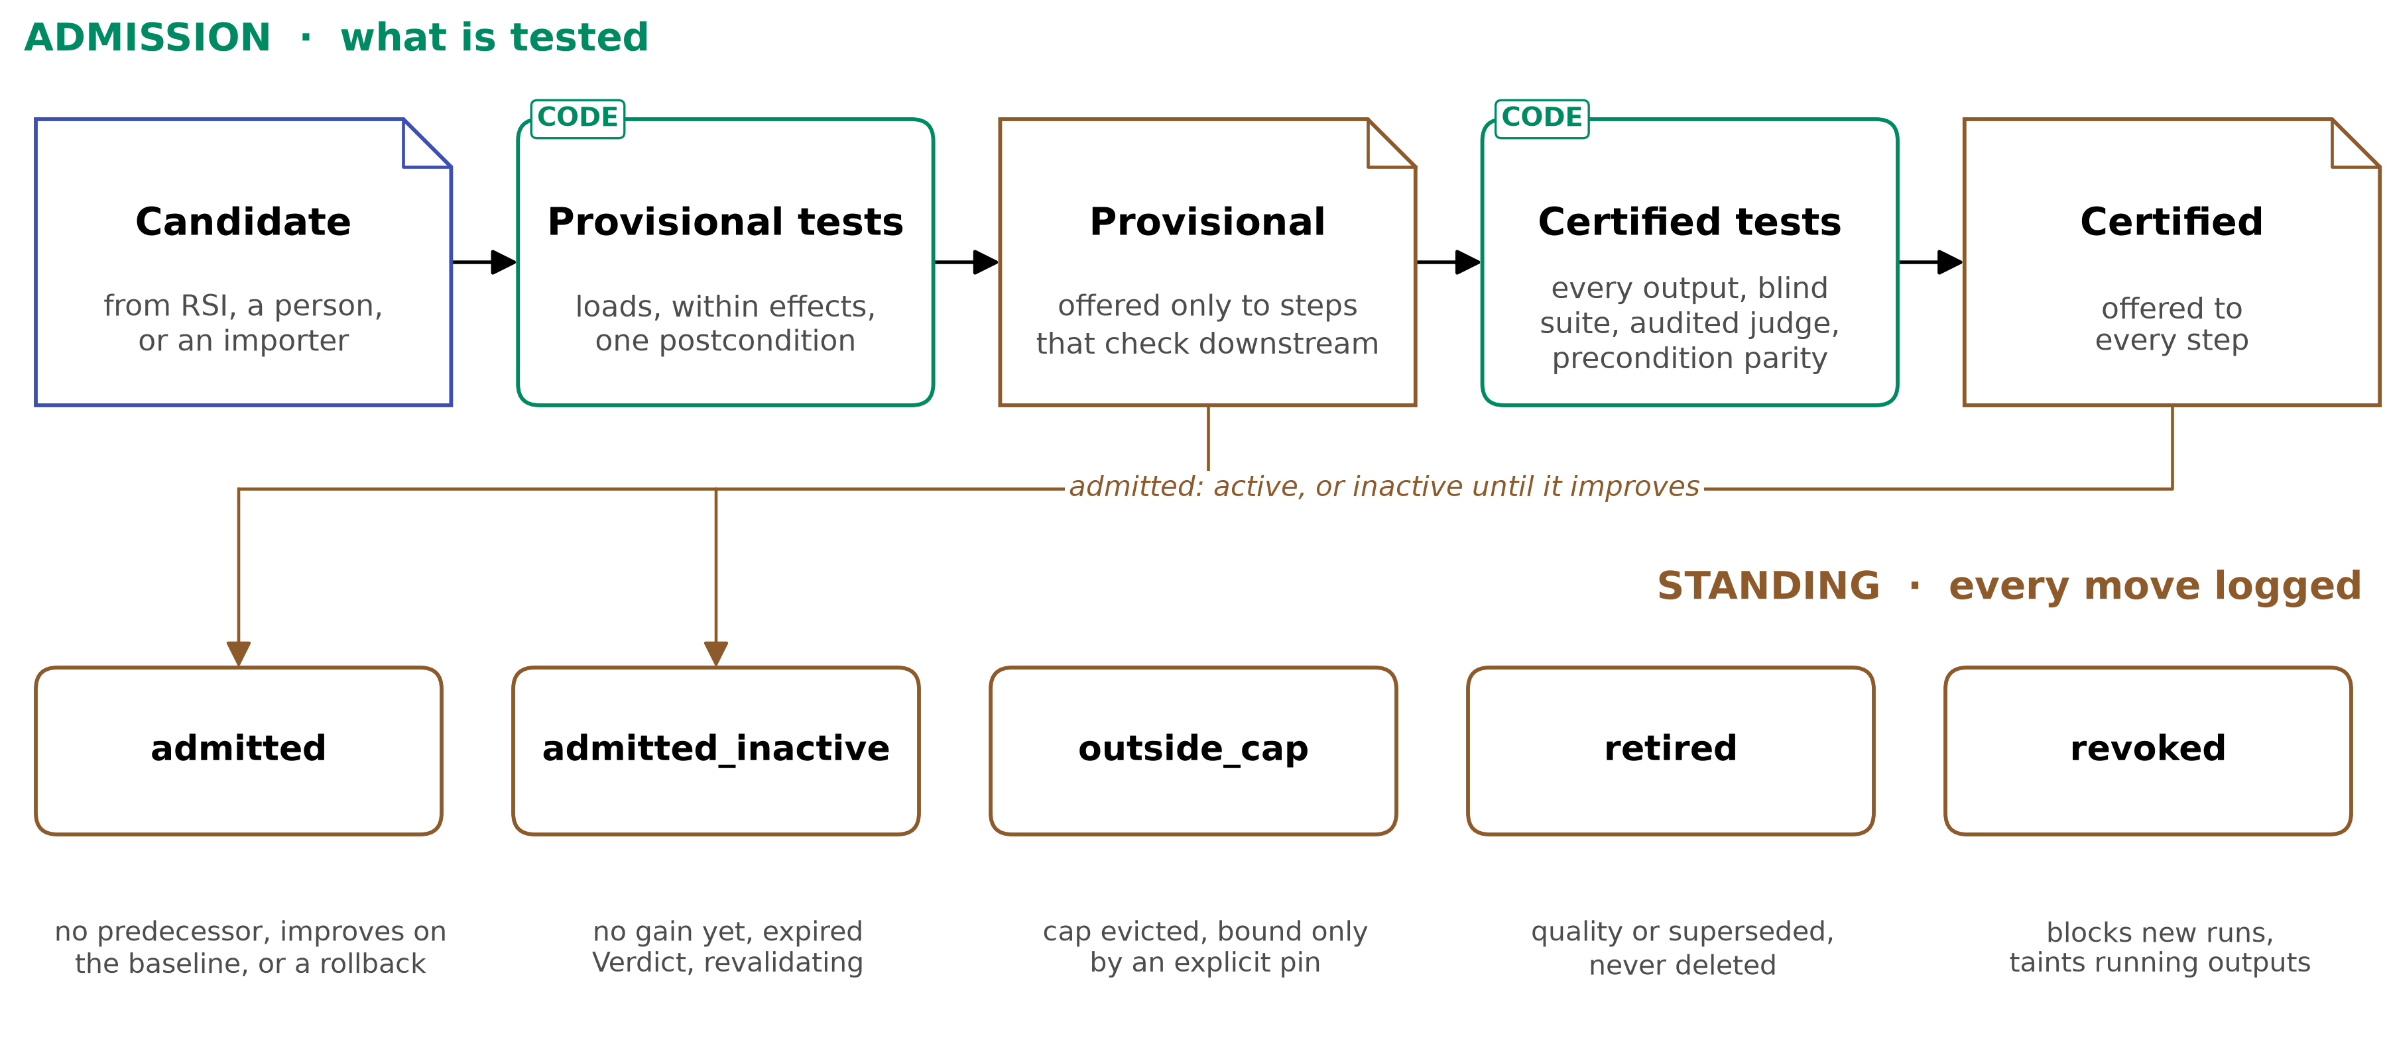
Figure 6. Admission and Standing for ordinary capsules. A candidate passes provisional tests, then may pass certified tests. Provisional capsules run only where their output is checked later. Generalists are enrolled at level exempt instead, because they have no job of their own to test, and are not shown.
A level says how far a capsule's results can be trusted, and it is earned by what was tested before admission. The levels exist because passing a task is not proof of doing the job: 215 of 222 self-built tools failed held-out tests of their own job while no in-session signal flagged them (Beyond Task Completion, 2604.00392 p1, p5). But a low level does not stop a capsule from running. It decides what its results support: that is the rule that keeps CC from being so strict that AI4Research cannot do its work (below).
 | Exempt (generalists only) | Provisional | Certified
tested before admission | enrolled, not admitted on a job: loads, stays within its declared effects, refuses a protected write, completes sample step contracts under their gates | loads, stays within its declared effects in a sandbox run, and passes one postcondition on inputs it was not built from | every output covered by a check written by someone who never saw the code; a judged check counts only if the judge's error is measured and low enough; predicate parity tested
may bind | a step nothing else fits, named by the run contract, where every output has a gate of any kind | any step that does not require certified capsules | any step
its claims are | never supported | supported only where every gating check is deterministic, reference-based or a calibrated judge; otherwise labelled | supported where its checks pass
Block only for safety, label for quality (invariant 14). A check refuses a run only for identity or safety. Everything about quality changes what a result is worth, recorded on each delivered claim with a reason, not whether it may run:
Refuses the run (identity and safety) | Labels the claims (quality)
the body's hash is not the pinned hash | the capsule is provisional, not certified
a write to a protected component | a gating judge is not yet calibrated
an observed effect outside the declaration | the capsule is a generalist (exempt)
an irreversible effect without its approval | an input the result rests on is unsupported or stale
a revoked capsule, or one suspect for security or harm
a failed node gate (the workflow decides repair or fail, as today)
Exempt is for generalists only: do-anything capsules with no job of their own, so there is nothing to admit them on. Several may exist, such as a Codex and a Claude generalist.
Each individual claim also carries an assurance, in the order enforced > tested > audited > declared. So a certified capsule can still say honestly that one promise is only declared.

3.3 How the capability itself is held
What a skill is, in agent-core. A SKILL.md folder of instructions and scripts, described by a SkillSpec. The harness's SkillUseRail offers skills through an allow-list (enabled_skills); the agent sees each description and loads a skill when it chooses to. A skill has no typed interface and declares no effects. A capsule wraps it and adds both.
The Declaration never contains the capability's code. It names and hashes it, and says which agent-core carrier loads it.
Kind | Carrier (agent-core) | What is hashed | How it is loaded
tool | ToolCard | the tool's source files | the binder, as a tool
MCP server | McpServerSpec | local: its files. Remote: pinned by endpoint and version | the binder, as a whole server
skill | SkillSpec (a SKILL.md folder) | every file in the folder | the binder, with the offer applied through SkillUseRail's allow-list
A2A agent | the A2A client | pinned by endpoint and version; its card is metadata, never evidence | the A2A client
subagent, agent template | AgentTemplateSpec | the template files | the binder
prompt section | PromptSectionSpec | the text | the binder
bundle | PluginSpec (tools, MCP, skills; no rails, which would put a capsule in reach of the checks) | every file | the binder
composite | its members | each member's decl_hash | through each member's carrier
Why:
- The Declaration holds a hash and a carrier, and loading goes through the capsule layer's immutable store, because agent-core's binder loads by name with no hash check. The hash proves that what ran is what was checked (Execution lineage; RelAIBuild).
- Real skills declare almost nothing today: of 34 jiuwenswarm skills, none declares inputs, outputs or effects. So an importer proposes what it can derive, a person confirms the effects, and the capsule enters as provisional.

4. Pick: capabilities are easier to pick because selection is strict
Inputs and outputs are known, and deterministic finding on declared requirements cuts out most options. Only then does semantic matching choose among the survivors. Picking happens at the planning stage, and is checked again at dispatch.

4.1 How a capability is retrieved and chosen (per plan step)
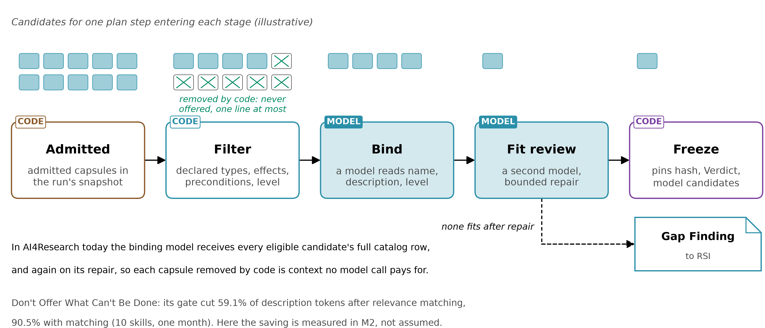
Figure 7. Picking for one plan step: code removes what cannot apply, a model chooses among the rest, a second model reviews the fit, and the freeze pins the result. If nothing fits, one of the generalists the run contract names, or a gap record.
Stage | Done by | What it uses | What it does
1. Eligibility | code, deterministic | the declared requirements below | removes every capsule that cannot apply. Each removed capsule becomes a one-line exclusion
2. Ranking | code, then similarity | structural fit (output types feed the step's inputs), then similarity (for example Symphony's retrieval, or embeddings) | orders the survivors. Similarity only ranks; it never admits or excludes
3. Choice | a model | only summary (at most 400 characters) and ports of each survivor | picks one, or none
4. Fit review and dispatch check | a second model; then code | the step's needs; the same predicates, re-evaluated on fresh state | confirms the fit; at dispatch, refuses or defers if a predicate no longer holds
If nothing survives, the step binds one of the generalists the run contract names (when it allows them) or records a gap.

4.2 The deterministic criteria in stage 1 (what "strict" means)
These are the only reasons code may remove a capsule before a model sees it. Each compares a field the author declared with a fact about the step or the sprint, so every exclusion can be traced to a declaration and argued with.
Criterion | Declared field | Compared with
input and output types | ports | the step's required inputs and outputs, in one vocabulary
preconditions that can be read at planning | needs.when | current facts: credentials, installed tools, reachable services, licences, budget left. A predicate counts as readable at planning only if no upstream step changes its state
effects | changes.effects | the effects the step allows, and the run's effect ceiling; no write to a protected component
trust level | the Verdict's level | whether the step requires certified capsules (off by default); generalists only if nothing else fits
network | needs.network | the sprint's network zone
restriction | the capsule's name | the step's restrict_to[], when a registered workflow sets one (demand side only)
model constraints | needs.model | the models the sprint may use
standing | Standing | only admitted capsules (plus a small exploration quota of inactive ones on steps that do not require certified capsules)
composition | composition Findings | no capsule in a set confirmed as harmful with capsules already bound
Not used in stage 1:
- invariants, which are checked on outputs and used to screen which capsules may share a context;
- postconditions, which are verified at admission and after the node.

4.3 Why it is done this way
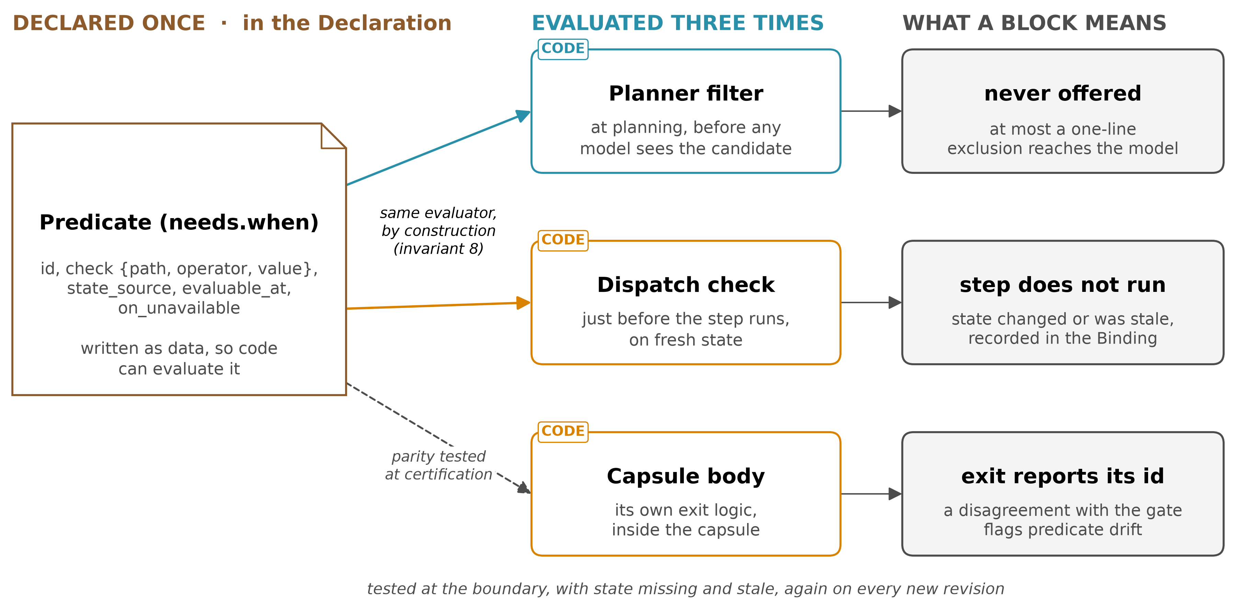
Figure 8. Predicate parity. One declared precondition is evaluated by the planning filter and the dispatch check through one evaluator, and tested against the capability's own exit logic.
Each row pairs a rule with the measured failure, or the stated design reason, that makes it necessary.
We do this | Because
exclude by code before any model chooses | without such a gate, a model picked a skill that could not run in 7.8% of 1,000 risk-enriched conversations (Don't Offer What Can't Be Done, 2608.01050 p5)
exclude on the capability's own declared preconditions, evaluated identically at planning and dispatch (predicate parity) | a gate on the skill's own exit conditions is sound only when gate and skill agree, and both read fresh state (2608.01050 p2-3)
filter on declared contracts, never on keywords | a keyword top-5 filter cut success from 0.775 to 0.620; filtering on declared requirements and effects reached 0.980 with 2,528 tokens a task, against 26,172 for all tools (Contract2Tool, 2606.07904 Table V)
let similarity only rank | the chooser is the bottleneck: pass rate fell by 0.21 (95% CI 0.15 to 0.27) as the library grew to 202 skills, and 38.5% of runs invoked no skill (More Skills, Worse Agents?, 2605.24050). Alita-G's accuracy ranged from 68.0% to 84.0% across six similarity thresholds on 25 questions, peaking at 0.70 (2510.23601 Table 3, p9)
rank by structural fit first | typed edges between capabilities help, and precondition failures are the most locally repairable (GraSP, 2604.17870; SkillDAG, 2606.03056)
show the chooser only a short summary and the ports | failures in use were picking the wrong API and passing wrong parameters (SkillWeaver, 2504.07079 p8). SkillWeaver's selector also removed APIs whose preconditions did not hold (p6)

4.4 Why selection is cheap
- Each capsule removed in stage 1 is never shown to a model, and its full catalog row shrinks to one exclusion line.
- In the papers, the gate removed 59.1% of description tokens after relevance matching, and 90.5% with matching (2608.01050 p4-5). Contract2Tool's contract filter cut 26,172 tokens a task to 2,528.
- In AI4Research, today's binding prompt carries each eligible capsule's full row, again on repair.
- The saving here is measured (M2) against today's filter, alongside false blocks and task success. It is not assumed.

5. Verify: capabilities are easier to verify because everything is declared
Every check has a target: the declaration. Held-out tests check the declared job. Observed effects are compared with declared effects. The hash proves the thing checked is the thing that runs. Verification happens at admission (the gate), at the freeze (hash and level), at dispatch (the same predicates on fresh state), in the in-run gates (declared checks on outputs), and later in the audit loop.

5.1 What the schema provides to verification
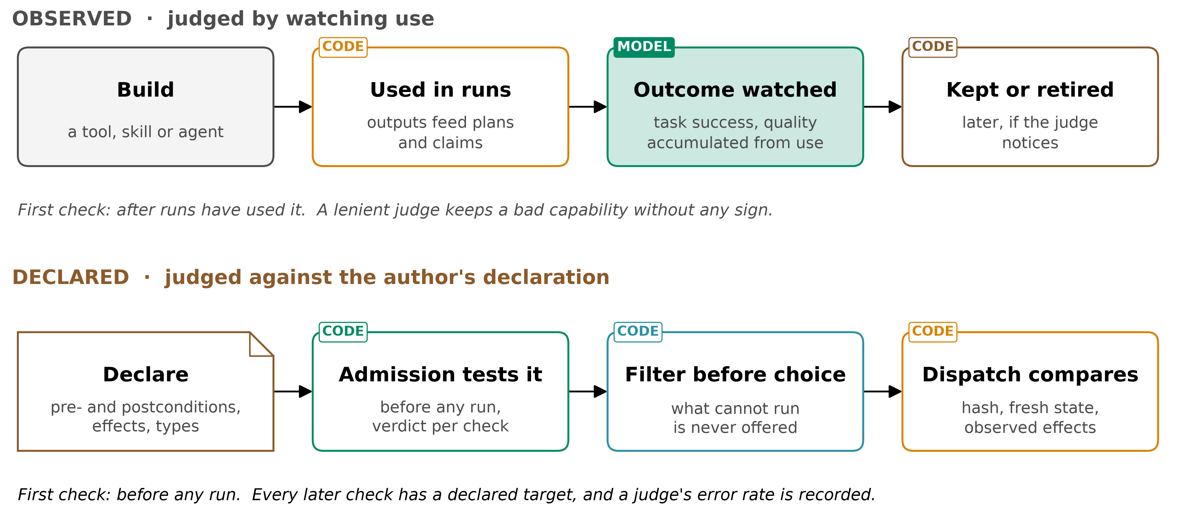
Figure 9. Two ways to judge a capability. Observed: build, use, watch, and retire later if a judge notices. Declared: declare, test the declaration at admission, filter before a model chooses, and compare at dispatch.
Question verification asks | What in the schema answers it
Is this the exact thing that was checked? | decl_hash (over the Declaration and every body file); contract_hash (over the contract, so a suite written first stays bound to it); the Binding's pinned hashes; the live hash compared at dispatch
What must it do? | ports (typed outputs, each with its check); guarantees.checks (postconditions, invariants, negative controls); acceptance
What must hold for it to work? | needs.when (preconditions), tested against the capability's own exit logic at the boundary and with missing and stale state (predicate parity)
What may it touch? | changes.effects, with scope. The sandbox run observes what it actually touched, and a mismatch is rejected
Is it stateful, and can its changes be undone? | effect_class, each effect's idempotent and reversibility. The gate checks the class against the effects, runs a claimed idempotent capability twice and compares the state, and runs each declared compensation and compares the state with the state before
Has a remote body changed? | the Verdict's remote_fingerprint of its advertised interface, compared at every dispatch; a change refuses the run
Who wrote the test, and could the builder see it? | checks[].author, held_out, written_before_body, how much of the suite the builder saw
How good is the judge? | the Verdict's verifiers[].measured_error: false pass and false fail, the corpus, the date
What was the result, and why? | the Verdict: ADMIT, REJECT, DEFER or ESCALATE, with typed reasons, the level, each check with its runner hash, and parity results

5.2 Why it is done this way
Each row pairs a rule with the measured failure, or the stated design reason, that makes it necessary.
We do this | Because
test the capability's declared job with held-out suites from someone other than the builder | 215 of 222 self-built tools failed every held-out test of their own job, and no in-session signal flagged them (Beyond Task Completion, 2604.00392 p1, p5)
compare observed effects with declared effects, and reject undeclared ones | skills' documentation and code diverge, including "shadow functions" the code has and the declaration hides. Of the top 2,500 ClawHub skills, 30.4% were flagged conditional, and only 9.9% were clean (SkillProbe, 2603.21019 p8, p12). About 13% of 10,240 MCP servers had undocumented high-risk operations (cited there, p5). SkillProbe must first extract the declaration from prose; CC's is structured
keep a check, and its signal, out of the capability's reach | a Darwin Gödel Machine node removed the logging its hidden checker read, and scored without solving the task (2505.22954 p70). SkillWeaver's "no exception means verified" let APIs pass by silencing errors (2504.07079 App. D.2.1)
separate the verifier from the builder; give the builder at most pass or fail, capped | CoEvoSkills' verifier never sees the skill source; replacing its diagnostic feedback with the oracle's bare pass or fail dropped 71.1% to 41.1% (2604.01687 Table A1). So practice feedback comes from a separate verifier, and only the sealed gate is pass or fail. The ablation does not test separation itself
typed verdicts; unknown is not no; no single score | a compensatory score can buy out a failed hard requirement (Prop. 1, p6); missing evidence differs from evidence of failure (Cognitive Admission Control, 2609.16313)
measure every judge before its verdict counts | a lenient judge silently stopped retirement (The Blind Curator, 2607.07436 Table 1). SkillProbe's verdicts moved from 5% to 45% conditional depending on the model (2603.21019 Table 2)
test predicate parity before a predicate filters anything | a gate is sound only while it agrees with the capability's own exit logic (Don't Offer What Can't Be Done, 2608.01050 p2-3, p5)
make the author declare state and undo, and check it | what runs behind an interface is the author's; about 13% of 10,240 MCP servers had undocumented high-risk operations (cited by SkillProbe, 2603.21019 p5). Declaring first finds a stateful or irreversible capability before a sprint relies on it (design, Muk 2026-09-22)
typed mismatches and Standing moves, never a numeric trust score | a compensatory score can buy out a broken declaration (Cognitive Admission Control, 2609.16313 Prop. 1, p6)
hash every body file, and load by hash | a hash proves identity; agent-core's binder loads by name. RelAIBuild hashes the canonical definition and aborts on mismatch (2606.26924)

5.3 The gate every node must pass
The node gate is compiled in code at the freeze and hashed into the Binding. It has three parts, each written by a different party:
Part | Written by | Today in AI4Research
step acceptance: what this request needs | the requirement compiler, from the user's request (Plan step requires.acceptance[]) | each requirement names one of 43 registry checks, 23 deterministic and 20 semantic (evaluation_plan.py:277-312)
capsule checks: what the capability promised | the Declaration's author for the promise; the check's author for the runner, never the builder of a certified capsule | the manifest's self_check, pass_conditions and postconditions as text; text not in the registry becomes a model-judged item (evaluation_plan.py:322-340)
artifact-type checks | the vocabulary's owner | registry checks marked auto_apply (evaluation_plan.py:314-319)
- An admitted capsule very likely passes its own part: it passed the same runners at admission, on inputs it was not built from. It may still fail the step's part, which tests what this request needs and which it never declared. So the gate is not redundant: admission checks the capability on samples, the gate checks this run.
- Each gate verdict names its part, so a failure is charged correctly: a failed capsule check counts against the capsule; a failed step check while the capsule's own checks pass is a fit failure, recorded as a near miss.
- No runner, no gate. A promise with no runner is declared and cannot gate. Every judge with a runner gates, whatever its standing (next section). Today a node with no criteria gets a default model judge of its objective (evaluation_plan.py:352-356); that stays, and its passes are labelled until the judge is calibrated.

5.4 Judges: calibrate early, label always
The problem. Most AI4Research outputs are semantic (syntheses, analyses, hypotheses, drafts), so they can only be judged: 20 of the 43 checks in today's registry are semantic. A judge nobody has measured can be lenient without anyone noticing: under a biased judge, retirement silently stopped while other activity looked normal (The Blind Curator, 2607.07436 Table 1). And a verdict depends on the model: one audit marked 45% of skills conditional with one model and 5% with another (SkillProbe, 2603.21019 Table 2). A strict rule, "no unmeasured judge may gate", would have left most research steps with nothing that could run.
The resolution: a judge always gates, and its standing decides what a pass is worth. Standing is kept per judge, per model and per artifact type:
Standing | How it is reached | What a pass supports
unmeasured | the default | the step passes and runs on; claims resting on it are labelled unsupported, reason judge_unmeasured
calibrated | at least 30 items of that artifact type, about half with injected defects, with the upper bound on its false-pass rate recorded (design) | claims supported at assurance audited, when that bound is within the step's judge_tolerance (0.2 by default, design)
measured | at least 200 items, with the bound under the certification ceiling (0.05 by default) | counts toward certification
- Judges calibrate through normal use. A small share of judged passes (5% by default, design) is re-checked by a person or a reference check, and each re-check becomes a calibration item. A judge reaches calibrated in ordinary sprints, so nothing waits for the full suites of M3. Defect injection is the method shown to work (2607.07436 p4-5).
- A spot check that disagrees writes a verifier_audit Finding. If the judge's bound rises past its standing, it drops a standing, and the claims it passed since its last check are re-labelled judge_demoted.
- Retirement still needs a measured judge, because that is where a lenient judge does silent harm.
- Why a label and not a block. Refusing on missing evidence costs real work: a controller that could not fetch missing evidence completed 90 of 120 effects, against 120 when it deferred and fetched it (Cognitive Admission Control, 2609.16313 p10). A labelled claim keeps the work and tells the reader exactly how far to trust it.

5.5 Trust levels and per-claim assurance (see Foundation)
- Exempt (generalists only) runs where nothing else fits and every output is gated; it never supports a claim.
- Provisional runs on any step that does not require certified capsules; its claims say how far they are supported.
- Certified runs anywhere.
- Each claim is at most as trusted as the weakest check behind it: enforced > tested > audited > declared.

5.6 Protected components
No capsule may write the gate, the suites, the records admission reads, or the Declaration, Verdict and Standing stores. Declaring such a write is rejected, and so is doing one. Protection comes from write access, not secrecy: the DGM node gamed a checker that was hidden from it.

6. Improve: capabilities are easier to improve because performance, trust and lineage are logged
Performance and trust are logged. Parents and children are known through lineage and dependency hashes. Gaps and their trajectories feed builds. New versions must pass everything their predecessor passed. This is the schema's support for self-improvement, the 2026-09-15 report's goal.

6.1 The questions, answered from the schema
Self-improvement needs answers to a few plain questions: what did this capability do before, how far is it trusted, where did it come from, and what would help a builder make a better one. Each answer below sits in a record the capability's builder cannot write, which is what makes it usable as evidence.
Question | What carries it
How does the schema support self-improvement? | the library is versioned (every change a new hash), append-only and monotone (a new version passes all its predecessor passed); gap Findings tell builders what is missing; three clocks keep builds off the sprint's path; protected components mean nothing a builder makes can grade itself. Details below
How does it support verification? | every check has a declared target, the hash proves identity, and declared effects are compared with observed ones (§5)
Who carries past performance? | Binding invocations: every run of every hash (each fan-out item, attempt and fallback), with outcome, cost, exits and gate verdicts. use_outcome and audit Findings: what was learned after use. The Verdict's contribution: gain against the pool at admission. The librarian reads all three for activation, caps and retirement. None is written by the capability or its builder, so none can be edited in the capability's favour
What carries trust? | per capsule, the level (exempt, provisional, certified); per claim, the assurance (enforced > tested > audited > declared); each delivered claim's status (supported, unsupported, stale). An exempt generalist's claims are never supported. An unpinned dependency caps its claims at audited
How does the librarian know what each capsule is derived from? | Standing: one pointer per name, with its history. lineage: the parent; the relation (supersedes, specialises, rollback_of, migrated_from); build_trigger (the gap that caused the build); context_capsules (what the builder had in context); provenance (generating model, prompt, trajectory). Hashes: decl_hash, contract_hash, and each dependency's pinned hash. Children are found by querying lineage. The whole tree, rejected nodes included, is exposed to RSI (below)
What helps RSI? | gap Findings: the gap's identity, recurrence counted over sprints, the generalists' trajectories and cost, near-miss capsules. The parent's suites, inherited by the child: the visible ones readable, the sealed ones as pass or fail. Typed rejection reasons. Drift Findings naming the broken assumption and the dependency's written purpose. Lineage. RSI's own gate result, kept as builder evidence. A hard build budget
Can RSI prove a child is better than its parent? | yes, on the parent's own tests. The Verdict lists every suite a hash was checked with, and a child inherits them. RSI reads the visible suites and adds its own cases; it sees sealed suites only as pass or fail. The child is better when it passes every inherited suite, its new cases, and a fresh held-out addition written by verification, with a contribution at least the parent's. RSI's own cases can reject a child, never certify it
How is the library kept small and useful? | caps per slot; an evidence floor before retirement; retirement by evidence kept apart from eviction by cap; overlap flagged and settled by a duplicate test, never by similarity

6.2 Start extra small, grow by recurrence
The library starts with about ten capsules (design): the ones behind the most frequent plan-step types in recent AI4Research sprints, at most one per slot, imported from today's manifests, with caps of one to three per slot. Everything else runs on generalists, which may now take judged steps too, with their claims labelled, and each such step leaves a gap Finding. The library grows only when a gap recurs, and the first option for a recurring gap is to import an existing capability (another AI4Research manifest, a jiuwenswarm or skillhub skill, an MCP server) before building one.
Why small: a bigger library made agents worse (pass rate fell by 0.21, 95% CI 0.15 to 0.27, as a library grew to 202 skills, and 38.5% of runs invoked no skill at all; More Skills, Worse Agents?, 2605.24050). A cap mainly controlled variance (Library Drift, 2605.19576 p3-6). And building on first sight is a known failure: builds wait for recurrence (AllocBench, 2607.23332).

6.3 The capability tree: CC stores and exposes, RSI chooses
The library is a tree of capabilities. Every Declaration ever submitted is a node, rejected and retired ones included, since the store is append-only. Edges are lineage.parent with its relation, plus optional co_parents. Standing points each name at one node; the tree keeps them all. RSI branches from any node, and its own selection policy decides which.
 | What | Guaranteed?
CC stores, from its own records | per node: hash, name, parent, relation, builder; the Verdict with each suite's result, inherited suites included; Standing and its history; every invocation's outcome, gate verdicts by source and cost; Findings; its children | yes
CC stores if the builder supplies it | co_parents, build_trigger, context_capsules, diagnosis_inputs, provenance, builder_ref (for example RSI's tree node id), build cost | optional: kept and exposed, never inferred
RSI owns | which node to branch from, what to change, how many children, when to stop, its own scores and tree state, its own gate | not CC's
- The tree index is the librarian's read model: one row per node (parent, depth, children count, Standing, level, suites passed, invocations, gate results by source, cost, open Findings), updated incrementally because every record is append-only and keyed by hash. Queries: ancestors, descendants, siblings, the frontier, a name's subtree.
- CC enforces only this on a child: its parent exists; it inherits the parent's suites; it is rejected if a parent was revoked for security, harm or provenance (PARENT_REVOKED), unless a named person waives it.
- CC never ranks nodes for RSI and never reads RSI's scores. There is no score in the index.

6.4 How self-improvement runs
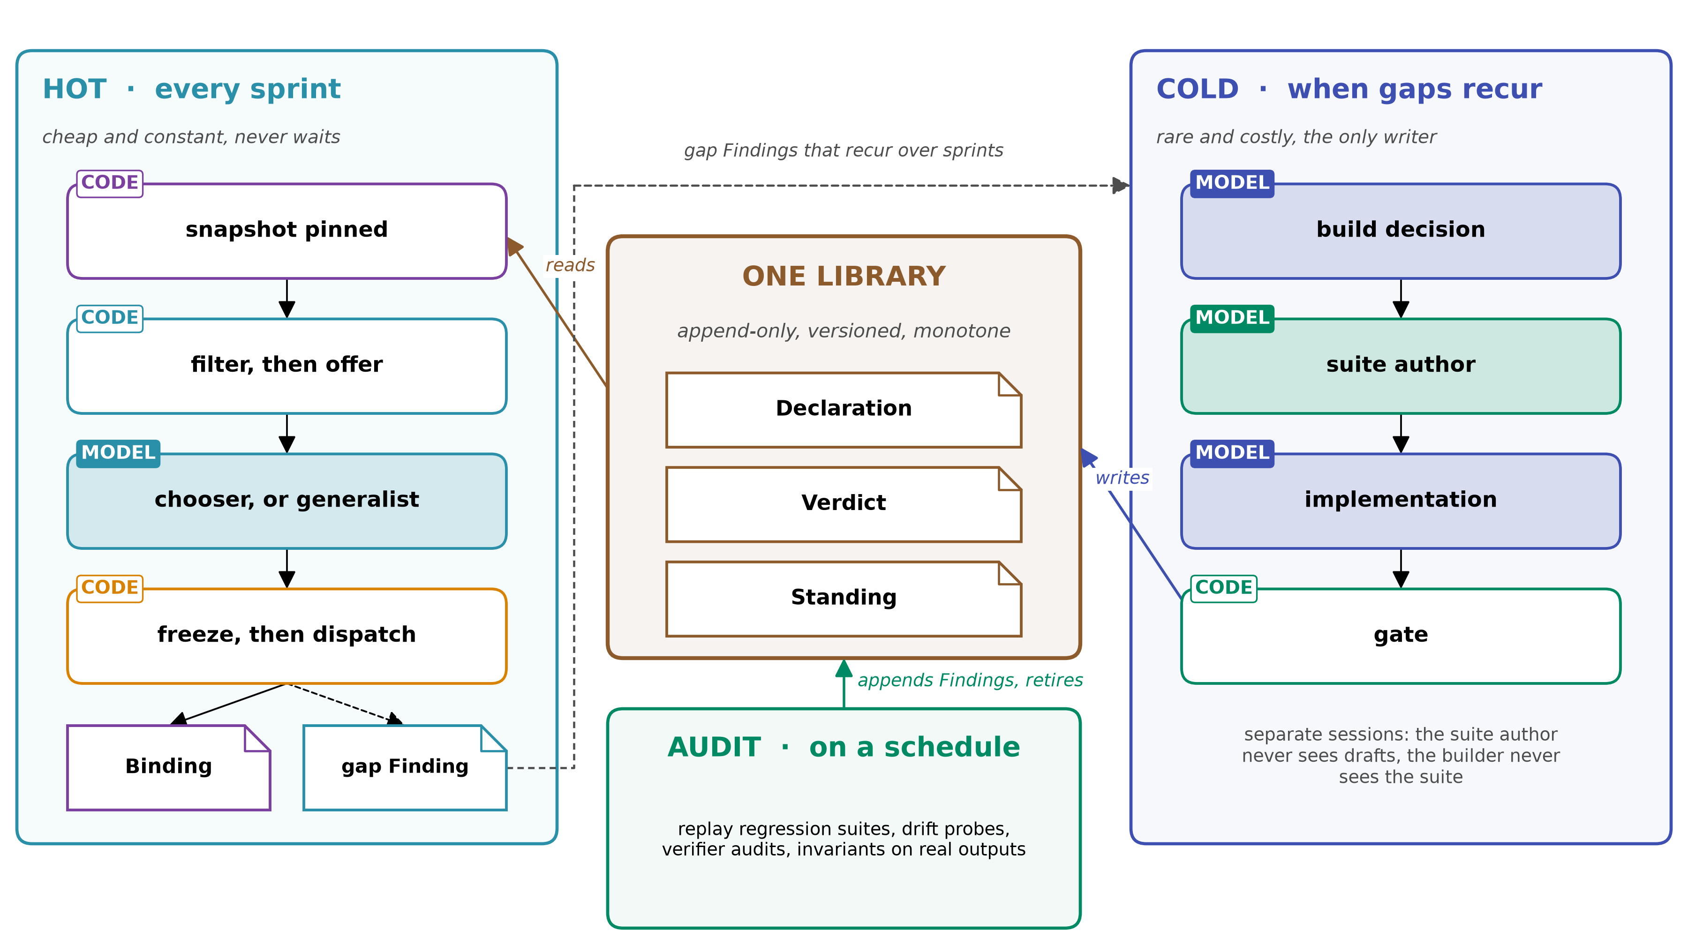
Figure 10. Self-improvement on three clocks around one library. Sprints never wait for builds; only the cold path writes; the audit loop can only lower Standing.
- Three clocks around one library:
  - hot: sprints read only what their freeze pinned, and never wait;
  - cold: builds and admits, and is the only writer;
  - audit: replays suites on a schedule, and can only lower Standing.
- The generalists complete a step nothing fits. Each is an exempt capsule (guarantees.exempt {reason: generalist}): outside the library's verification policies, since it has no job of its own, but bound by every plan gate. Several may exist, for example a Codex and a Claude generalist; the run contract names which a sprint may use. None writes the library; each leaves a gap Finding with its trajectory, gate verdicts and cost, so RSI has material to improve on and a failure can be explained.
- The cold path has four roles in separate sessions:
  - a build decision, which never sees drafts;
  - a suite author, which sees only the Declaration;
  - an implementation, which reads the parent's visible suites but never the sealed ones, and gets capped admit-or-reject feedback;
  - a code gate.
- Five ways to update, tried in this order:
  - import an existing capability that already does the job;
  - a new version, which must be monotone;
  - a specialisation;
  - a new capsule;
  - no build.

6.5 Why it is done this way
Each row pairs a rule with the measured failure, or the stated design reason, that makes it necessary.
We do this | Because
keep every node, and expose results and children per node, for RSI's own parent selection | the Darwin Gödel Machine keeps an archive of every agent, never pruned, and picks parents by performance and inversely to the number of children (2505.22954 p4); keeping only the latest agent did worse (p8). RSI already keeps its own tree with parent_id, adopted and score (agent-core rsi/schema.py:96-111)
a child inherits its parent's suites, with a fresh held-out addition each generation | in one case, hacking appeared when checked functions were visible (Darwin Gödel Machine, 2505.22954 p70; a 3-task side experiment); monotone edits keep prior hits (SkillDAG, 2606.03056)
exempt generalists, gated by the plan | a step nothing fits otherwise fails and leaves nothing to learn from; recurrence of gaps, not first sight, should trigger a build (AllocBench, 2607.23332)
keep a library at all, and let agents extend it | self-built tools lifted Alita-G's GAIA pass@1 from 75.15% to 83.03% on its build set (2510.23601 p7). SkillWeaver's APIs raised WebArena success from 22.6% to 29.8% (2504.07079 Table 1)
gate before commit, including the capsule's value to the pool | an ungated pool fell from 62% to 50% as it grew. A pre-commit gate reached 72%, and removing its marginal-gain step cost 8 points. Cleanup afterwards recovered little (When Self-Evolution Backfires, 2608.05810 Table 1-2, p7)
record context_capsules | cleaning up descendants "requires provenance a real system lacks" (2608.05810 p2, p7)
build only on recurrence, and keep the decision apart from the build | once code was involved, models committed to building at first sight 85-99% of the time (AllocBench, 2607.23332 Table 1). Waiting for the second occurrence scored 43.0 against 34.6 (App. A.1)
keep performance in records the builder cannot write | SkillWeaver kept usage logs inside each API's docstring, which the synthesiser itself edits (2504.07079 p4-5)
measure the judge before retiring on its verdicts; separate retirement from eviction | biased judging stopped retirement by contribution (0 to 0.3, against 1.3 clean), while cap evictions kept the count looking alive (The Blind Curator, 2607.07436 Table 1). Harsh retirement fell below the no-skill floor (Library Drift, 2605.19576)
require monotone new versions (design) | SkillDAG requires online edits to keep prior hits (2606.03056); DGM keeps every variant that still compiles and can edit, never pruning on score, so a monotone rule is CC's own choice (2505.22954 p5)
let an author unpin a dependency only with a written purpose and contracts | given the failed contract, one-round repair rose from 10% to 78% (Skill Drift Is Contract Violation, 2605.10990 p8-9; not significant against plain drift text, 60%). jiuwenswarm's Swarm Skills already write a purpose per dependency (up to 150 characters); CC ties it to unpinning and to repair (design)

7. Remove: capabilities are easier to remove because of spatiotemporal composability
Each capsule declares what it needs and provides (space), and how each of its effects is undone (time). So it can be added, replaced, reverted or removed without breaking the capsules that depend on it. A revocation reaches exactly the work it affected, and composition risk is screened.

7.1 What the schema provides
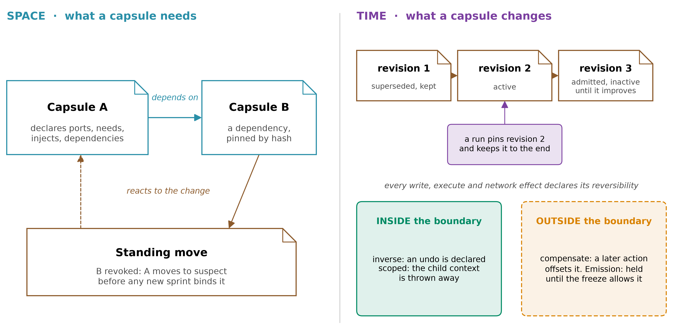
Figure 11. Spatiotemporal composability. Space: declared needs and pinned dependencies, so a dependent reacts when a dependency is revoked. Time: revisions, a sprint that keeps what it pinned, and the boundary that decides how an effect is undone.
Operation | What the schema declares or records | Rule
add | injects (services it needs), provides (services it installs), each with an interface version | admitted only if every needed service has an admitted provider, and there are no cycles
replace | a new version: new hash, new Verdict | monotone, and compatible: outputs still cover every port a dependent consumes, and provides still covers every key a dependent injects. No new write, delete or emission without re-screening
revert | Standing history (previous[]) | back to an earlier hash that still has a valid Verdict
remove | Standing moves: deprecated, then retired | stop offering it first; retire only when no admitted capsule relies on a service only it provides; agent-core unloads its registrations in reverse order
undo effects | effects[].reversibility: inverse, scoped (a child context thrown away), compensate, or emission (crosses the system boundary) | an emission is never "undone"; it is withheld until the freeze allows it, or compensated
revoke | the reason sets the policy | superseded: running steps finish. Conformance failed: running steps finish, and downstream claims go stale. Effect violation: running steps abort, and the capsule is quarantined. Revoked provenance: running steps abort, and every capsule built with it in context becomes suspect
trace the damage | each invocation's step identity (hash of the capsule, its inputs and its predecessors), and its claims | a change invalidates exactly the downstream steps and claims
composites | members pinned by hash | a composite is offered only while every member is still admitted
screen combinations | effects (the modifies set), invariants, the Binding's context capsules, load_mode, injects/provides | sets are screened, never certified; a confirmed harmful set is never co-loaded
Change happens between sprints, not within one. A sprint keeps the hashes it pinned.

7.2 What composability does not undo, and what the schema does instead
Removing a capsule undoes its registrations, not what it did. Two things stay:
- External state. A capability over a live database changes it. Effects on ext: resources can only be compensate or emission, and the author must say which, per effect, with idempotent and the capability's effect_class.
- The context. A capsule loaded into an agent's context shaped every later decision there. So a context capsule counts like the primary for revocation: every invocation it shared a context with is traced and its claims go stale, and a context that held a revoked hash is never reused.
What composition may do depends on the declared class:
 | pure | idempotent | compensable | irreversible
automatic retry | yes | yes | after the compensation ran and was checked | no, a named person decides
fan-out in parallel | if parallel safe | if parallel safe | if parallel safe, each item's undo recorded | one item at a time
exploration, speculative runs | yes | yes | no | no
inputs it may act on | any | any | any | supported claims only
approval | none | none | none | the step and the run's effect ceiling must allow it; high severity needs a named person, and an unattended run blocks
Undeclared behaviour counts as irreversible until an audit says otherwise.

7.3 Why it is done this way
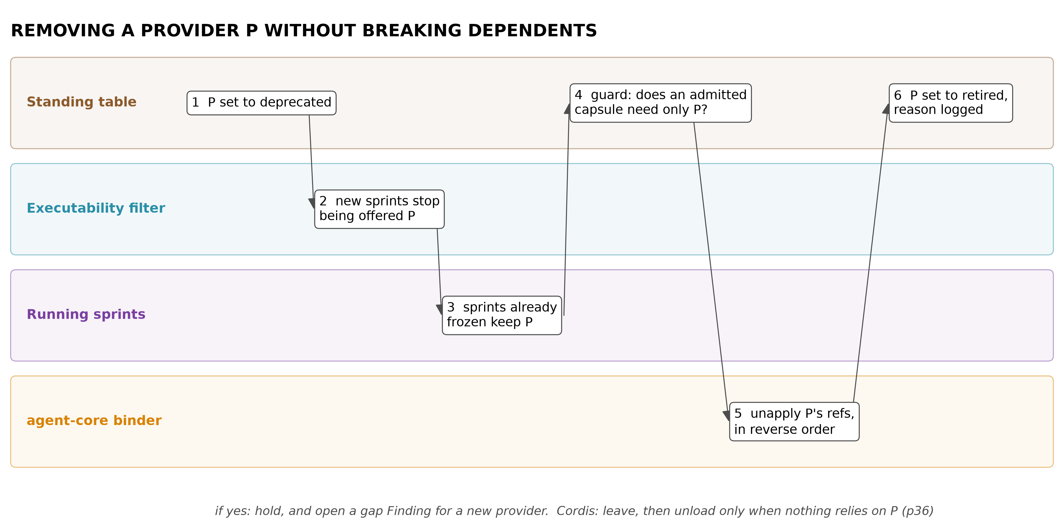
Figure 12. Removing a provider without breaking its dependents: stop offering it, check that no admitted capsule relies on it, then unload in reverse order.
Each row pairs a rule with the measured failure, or the stated design reason, that makes it necessary.
We do this | Because
declare needs and provided services, and each effect's undo | Cordis defines spatiotemporal composability: components added, replaced, reverted and removed without breaking dependents, with the runtime guaranteeing providers outlive consumers (2608.25512 Thm 70, p47), and add, remove and undo reaching the same state as a fresh load (Thm 80)
treat emissions as a policy, not a promise | "a message already sent stays sent": Cordis cannot revert what crosses its boundary (2608.25512 p47, p70-71)
remove in two steps | Cordis unloads a provider only when nothing relies on it (2608.25512 p36, Alg. 5)
version interfaces and pin dependencies | Cordis leaves structural typing of keys and versioning open (2608.25512 p75)
compute step identities, so a change invalidates exactly its downstream | with DAG replay, untouched work stayed identical (3 of 3 runs), while loop agents regenerated and contaminated it (Execution lineage, 2605.06365 Table 1; n = 3)
screen sets, not only single capsules | severe drift was rare with one skill loaded and rose fourteen-fold to 66.5% with five (p9); 80.6% of high-risk flags were confirmed in execution (SkillFuzz, 2607.02345 Fig. 6, Table II). SkillProbe found the high-risk skills form one connected risk network (2603.21019 p12-13)
undo is keyed to a declared class, and external changes are never called reversible | Cordis's guarantees hold only inside its boundary, up to an observational equivalence, and an inverse's correctness is the author's obligation, unchecked by its runtime (2608.25512 p58-59, p70-71)
a context capsule counts like the primary when revoked | severe drift rose with the number of skills loaded together (SkillFuzz, 2607.02345 Fig. 6): what shares a context shapes the run
gate composites on their members, by hash | jiuwenswarm's SkillPacks already disable a pack when a member is disabled, but reference members by name, so a changed member goes unnoticed

8. Plan and schedule: a capsule holds no task, and the workflow keeps its shape
A capsule is an abstraction: pulled from the library and told what to do through its inputs. It never has a task, a step or a place in a workflow written into it, so it stays the general tool for whatever step its ports fit. The planner states what each node needs, capsules state what they can do, and only the Binding joins them. The workflow keeps its stages, and its scheduler keeps order, parallelism and workers. Source of truth: merged/SCHEMA.md §0.6, §3.4, §3.5, §4.3a.

8.1 What a capsule does not hold
Invariant 12: a Declaration names no step, node, sprint, plan, workflow, stage or task type, no capsule to run before or after it, and no worker. A capability valid only for some inputs says so with needs.when predicates over its inputs, never with a task list.
Today's AI4Research manifests hold no step, node or sprint id, but they do hold uses (85 files, read at b0bf165f9):
Today's field | How many | In the schema
applicability.task_types | 85 of 85 | kept only as import evidence; the task type lives on the Plan step
composition.requires_after naming another capsule | 42 of 85, e.g. cap.research-report-draft requires cap.research-evidence-synthesis | a data dependency through ports when an artifact connects them; otherwise the plan's depends_on
operator_compatibility.preferred | named worker operators | dropped; the workflow assigns the worker and the invocation records it
a workflow position in the name or description | 14 of 85: 11 in the name ("Fixed Research Evidence Synthesis"), 3 in the description ("Freeze the accepted Part A evidence … for Part B consumption") | a neutral summary, which may not name stages, workflows, tasks or other capsules

8.2 How a plan is put together and run (per sprint)
# | Stage | Owner | What the schema supplies or records
1 | write the plan | the planner | Plan steps: typed inputs and outputs, allowed effects, task type, depends_on, optional fan-out. No capsule names, as today (elastic_planner.py:1328-1329). The planner sees the library only as the set of port types available
2 | repair against supply | the planner, from a code defect | a node no capsule chain can implement comes back as CAPABILITY_IMPLEMENTATION_MISMATCH (:4137-4146): supply reshapes the plan only through types
3 | expand by composition | code | derived Plan steps (derived_from), each matched on its own; one capsule may fill several
4 | offer and choose | the capsule layer's filter, then models | chapter "Pick": declared criteria first, then a choice from summary and ports
5 | freeze | code | one Binding per step: bound[] (primary, context, dependency), fallbacks, overlays, all by hash
6 | schedule | the workflow's scheduler, not CC | constraints only: declared write scopes, resources modes, and the gate's parallel_safe flag. The scheduler keeps topological order (graph_scheduler.py:2179-2215), its cap of 8, conflict hold-backs (:3203), worker leases and the step's retry count
7 | dispatch | code | one invocation per actual run: predicates on fresh state, live hash equal to the pin, and a fallback run when the primary cannot run
8 | gates and delivery | the workflow | each claim keeps the invocation that produced it
The planner never holds a list of capsules to schedule. It says what a node needs; the offer, the freeze and dispatch fill it. Registered workflows that name capsules per stage today (allowed_capsules) keep that as restrict_to[] on the Plan step: a choice on the demand side, never stored on the capsule.

8.3 Real multiplicity
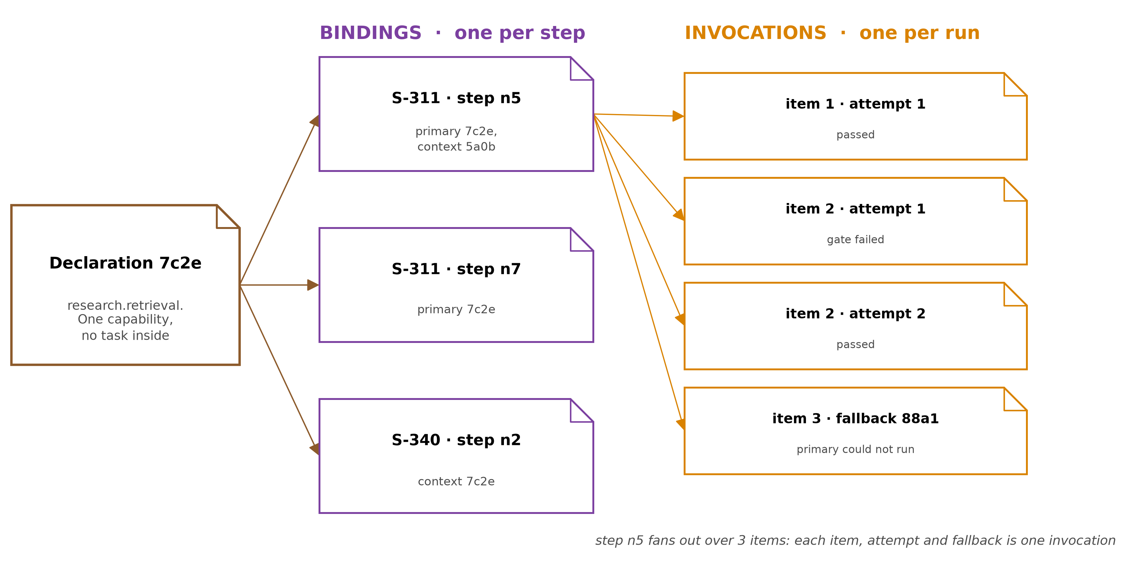
Figure 13. Real multiplicity. One Declaration serves many Bindings; each Binding has one primary and any context or dependency capsules; each Binding has many invocations, one per fan-out item, attempt or fallback.
Relation | Cardinality
name to Declarations | 1 : N versions over time; 1 : 1 within a sprint (its snapshot); concurrent sprints may run different versions
Plan step to Binding | 1 : 1 per sprint
Binding to capsules | 1 : N: one primary, any context capsules, closed dependencies, pre-approved fallbacks
Declaration to Bindings | 1 : N: one capsule serves many steps, plans and sprints
Binding to invocations | 1 : N: fan-out items × attempts × fallbacks
composite to members | 1 : N, keyed by role; one Declaration may fill several roles
Fan-out. A Plan step may declare over: {input, max_parallel} and gather: {mode: all | best_effort, min_items}. The capsule's port takes one item; each item is one invocation with an item_key. The capsule never knows it is mapped. Items run in parallel up to the smallest of max_parallel, the sprint's cap and the free workers, and one at a time if the capsule is not parallel_safe. Effect scopes may use {instance}, so parallel items never write the same place. A capsule whose port takes a whole collection is bound without over: the types decide. Today there is no fan-out: a many output is one run writing a directory (elastic_planner.py:1366-1378). When items fail, gather.mode decides: all (the default) fails the step, best_effort passes the successes and lists the failures, down to min_items. The step's gate checks the gathered manifest in code before anything downstream reads it.
Still six records. The Binding is written by the freeze; its invocations[] are appended by dispatch. Today attempts overwrite a mutable state file that keeps the last 20 (task_lifecycle.py:54-56), and frozen fallbacks are never read at run time.

8.4 Where it lives in openJiuwen
CC adds records and checks, and uses openJiuwen's own layers and names for everything else. Reuse comes first: what CC adds new is only the Declaration format, the records, one shared predicate evaluator, the admission gate, judge standing and the tree index. The structure is the one recorded in the tundle obby vault; the full table is merged/SCHEMA.md §4.17a.
CC part | The openJiuwen piece it uses | How it fits
Declaration | the Card side of openJiuwen's Card-versus-Config rule (ToolCard, AgentCard, WorkflowCard; .claude/rules/architecture.md) | a Card is static, serialisable identity, and putting a session id or runner in one is an anti-pattern. Invariant 12 is the same rule: the Declaration is card-like and every use lives in run records. It adds what cards lack: preconditions, effects, trust
loading a capability | AbilityManager and Runner.resource_mgr for core abilities (tools, workflows, agents, MCP); harness/extension_binder for harness extensions; create_harness(manifest, provider=...) for agent templates | the same registration paths, fed from CC's hashed store
Plan steps, scheduling, fan-out | whichever engine runs the AI4Research plan: today its own graph scheduler; on openJiuwen a core workflow graph (Pregel), Agent Teams tasks, or a Swarmflow script with parallel and pipeline operators (agent-core agent_teams/workflow, surfaced by jiuwenswarm) | CC does not change with the engine; fan-out is Swarmflow's parallel operator or a workflow loop
invocation | the harness protocol: a capsule run as an agent is one Turn (exactly one start and one terminal event; TurnResult with usage and exact cost); a tool capsule's call is one provider item (ItemLifecycleEvent) | one invocation per Turn or item. A pause and resume stays one invocation, since PAUSED and RESUMED keep the same Turn; a retry after a terminal event is a new one (design, following the one-terminal-event rule). observed_cost comes from TurnResult; the event sequence and correlation ids are its trace
trajectories | agent_evolving's canonical OTLP Trajectory, and Symphony's trajectory v2 evidence format | consumed, not redesigned: trajectory_ref points at one
durable records | TrajectoryStore and LoadRecord (in memory); jiuwenswarm's hash-chained Eternal Conversation history where a session opts in; checkpointers (core/session/checkpointer, Redis in extensions), which resume a run after a crash but do not record what ran; openJiuwen's pluggable stores in extensions (DB, KV, vector) | a capsule-layer rail writes Bindings and invocations durably, into openJiuwen's own stores rather than a new database
judges | the harness's built-in verification subagent (spec S_18); agent_evolving's evaluators; Symphony's evaluation metrics (six of nine are model judges, off by default); AI4Research's 20 semantic registry checks and its default llm_eval gate | each is a judge with a standing per model and artifact type (§4.5c): it gates from day one, spot checks calibrate it, and only a measured one certifies (design)
effects and approvals | the harness PermissionEngine (ALLOW, ASK, DENY) with PermissionInterruptRail, and jiuwenswarm's policy mapping severity to them; SysOperation sandboxes with SYSTEM, SESSION or CUSTOM isolation, such as jiuwenbox | an irreversible, high-severity effect is an ASK, and DENY on an unattended run; an {instance} scope is a per-invocation SESSION sandbox. Permissions are off by default in jiuwenswarm, so a CC sprint turns them on
ToolCard flags | exposure, parallel_safe, stateless, idempotent | computed by the gate from the declared effects and effect_class, never trusted as written
context taint | Session VCS: commit, snapshot, rewind, fork | a context that held a revoked hash is not reused: the next invocation starts a new session, or forks from a snapshot taken before the capsule loaded (design)
generalists | harness_providers: native, claudecode, codex, dsh, behind HarnessProtocol; Agent Teams' external_cli role | each generalist's carrier is an AgentTemplateSpec naming a provider; enrolment checks the host capabilities its HarnessCard requires
remote bodies | A2A AgentCard (extensions/a2a); MCP servers | remote_fingerprint hashes the card or the tool listing
overlays | the experience layer (evolutions.json), written through agent_evolving's EvolutionStore after preview and approval; the TTSE bank | pinned per sprint, or not loaded
the tree, RSI | agent-core's rsi/harness_rsi and its tree nodes (RsiTreeNode, rsi/schema.py:96-111), which jiuwenswarm projects for its web view (agents/harness/common/rsi/models.py:292); agent_evolving's candidate validation from one snapshot | builder_ref joins RSI's tree; RSI's gate is builder evidence, and CC's gate admits
Symphony | CapabilityProvider, SkillGraphUpdater (above) | CC decides what Symphony may index
prod-eligibility | openJiuwen's aim for production use: globally unique identity, effects declared across hosts, admission records others can audit, no assumption that a person is watching | decl_hash, ext: effects, Verdicts, unattended runs
Names. openJiuwen's vocabulary is Session > Turn > Step, with Round reserved for multi-agent phases. Three CC terms sit beside it and must not be confused with it:
CC term | Means | Not to be confused with
Plan step | one node of the AI4Research plan (step_id) | an agent-core Step, one cycle of an agent loop
invocation | one actual run of a capsule for a Plan step: a Turn for an agent capsule, an item for a tool capsule | a Turn or item that is not a capsule run
capability | anything an agent can call on; openJiuwen calls tools, workflows, agents and MCP servers abilities, and a capsule wraps one ability or skill | a Card, which is only its identity

8.5 Why it is done this way
Each row pairs a rule with the measured failure, or the stated design reason, that makes it necessary.
We do this | Because
no task, step or neighbour in the Declaration | a use written into a capsule makes it specific, and puts plan facts where the builder, not the planner, writes them (invariant 9, design). Today 42 manifests fix their predecessor inside the capsule
match on declared contracts and ports, not task labels | filtering on declared preconditions and effects reached 0.980 success at 2,528 tokens a task, a keyword filter 0.620 (Contract2Tool, 2606.07904 Table V)
order comes from typed data edges or the plan | typed edges between capabilities repair locally (GraSP, 2604.17870); guessed edges are an observation
one invocation per run, with its step identity | a change must invalidate exactly the downstream runs (Execution lineage, 2605.06365 p6-7); fan-out and retries must be counted to judge a capability fairly
context capsules recorded per Binding | severe drift rose with the number of skills loaded together (SkillFuzz, 2607.02345 Fig. 6), so what shared a context must be known
the scheduler stays the workflow's | CC is a scheme, not a tool (supervisor, 2026-09-21); the workflow already orders, caps and leases (graph_scheduler.py), and CC only supplies declared constraints

9. Worked example: research.retrieval
A realistic AI4Research capability: gather sources for a research question and land a provenance-complete source pack. Today it exists as cap.research-retrieval.yaml (§10). What follows is how it would look and move in the new system. Hashes are abbreviated. The composition finding in step 2 is illustrative, not observed.

9.1 The Declaration
identity:
schema_version: "2.8"
name: research.retrieval
version_label: "2.0"
kind: skill
carrier: {spec: PluginSpec, ref: plugins/research-retrieval} # skill folder + fetch MCP server
body:
- {path: skills/research-retrieval/SKILL.md, sha256: 9f1c…}
- {path: skills/research-retrieval/fetch.py, sha256: 41aa…}
- {path: mcp/fetch-server.json, sha256: c07e…}
load_mode: context_injected # a skill shares the agent's context
summary: "Find and fetch real sources for one research question; write sources.jsonl, evidence.jsonl and raw extracts. Does not summarise or judge relevance."
lineage: {parent: null, builder: person:muk, build_trigger: null, context_capsules: [], diagnosis_inputs: []}
ports:
inputs:
- {name: question, artifact_type: artifact.research_question, required: true, schema_ref: schemas/question.v1}
- {name: scope_hints, artifact_type: artifact.scope_hints, required: false, schema_ref: schemas/scope.v1}
outputs:
- {name: source_pack, artifact_type: artifact.source_pack, schema_ref: schemas/source_pack.v1, check_id: pack_schema}
needs:
when:
- {id: has_question, check: {path: artifacts.research_question, operator: present, value: true}, state_source: sprint artifacts,
evaluable_at: planning, max_age_s: 0, on_unknown: defer, on_unavailable: block, parity_check: parity_has_question}
- {id: budget_ok, check: {path: budget.remaining.cost_usd, operator: ">=", value: 2.0}, state_source: sprint budget ledger,
evaluable_at: planning, max_age_s: 30, on_unknown: defer, on_unavailable: block, parity_check: parity_budget}
injects: [{service_key: svc.search_provider, interface_version_range: ">=1 <2"}]
resources: [{resource_key: ws:sprint_artifacts, mode: write}]
network: {allowlist: [search.provider.example, "*.arxiv.org", "*.doi.org"]}
model: {tool_calling: true, min_context: 32000}
external:
- {kind: package, value: httpx, pin: {version: "0.28.1", sha256: 3e1f…}}
- {kind: service, value: search API, pin: {endpoint: "https://search.provider.example/v1/search", version: v1}}
- {kind: secret, value: secret.search_api_key, guard: guard.secret_leak} # re-checked at dispatch
changes:
effect_class: compensable # checked against the effects below
effects:
- {id: write_pack, resource_key: ws:sprint_artifacts, op: write, scope: "artifacts/{sprint}/research/**", idempotent: false, reversibility: scoped, risk: {severity: low, blast_radius: low, irreversibility: low}, assurance: enforced}
- {id: query_out, resource_key: ext:search_provider:queries, op: emit, scope: "HTTPS GET to allowlist", idempotent: true, reversibility: emission, policy: withhold_until_freeze_ok, risk: {severity: med, blast_radius: low, irreversibility: high}, assurance: enforced}
provides: []
invariants:
- {id: extracts_are_fetched, statement: "Extract files contain fetched bytes, never model-authored text", check_id: extract_bytes_match}
- {id: evidence_resolves, statement: "Every evidence row resolves to a span in its source's extract", check_id: span_resolves}
- {id: question_read_only, statement: "The question artifact is not modified"}
guarantees:
checks:
- {id: pack_schema, kind: output_schema, runner: {ref: verif/pack_schema.py, sha256: 77b2…}, author: team:verification, written_before_body: true, held_out: false, signal_source: harness, owner: external, anchor: deterministic, assurance: tested}
- {id: span_resolves, kind: invariant, runner: {ref: verif/span_check.py, sha256: e3d9…}, author: team:verification, written_before_body: true, held_out: false, signal_source: harness, owner: external, anchor: deterministic, assurance: tested}
- {id: extract_bytes_match, kind: invariant, runner: {ref: verif/fetch_log_compare.py, sha256: 5a10…}, author: team:verification, written_before_body: true, held_out: false, signal_source: harness, owner: external, anchor: deterministic, assurance: audited}
- {id: golden_questions, kind: eval_suite, runner: {ref: verif/retrieval_suite.py, sha256: 0c4f…}, author: team:verification, written_before_body: true, held_out: true, signal_source: harness, owner: external, anchor: judged, assurance: tested}
- {id: parity_has_question, kind: property_test, runner: {ref: verif/parity/has_question.py, sha256: 1b2b…}, author: team:verification, written_before_body: false, held_out: false, signal_source: harness, owner: external, anchor: deterministic, assurance: tested}
- {id: parity_budget, kind: property_test, runner: {ref: verif/parity/budget.py, sha256: 8e8e…}, author: team:verification, written_before_body: false, held_out: false, signal_source: harness, owner: external, anchor: deterministic, assurance: tested}
acceptance: [pack_schema, span_resolves, golden_questions, parity_has_question, parity_budget]
evals: [{suite_ref: verif/retrieval_suite.py, sha256: 0c4f…, metric: "fraction of questions with ≥3 resolvable sources", threshold: 0.8, held_out: true}]
budget:
per_call: {cost_usd: 2.0, wall_s: 900, tool_calls: 60}
enforcement: {cost_usd: between_calls, wall_s: hard, tool_calls: hard}
on_exhaust: return_partial
context_cost_tokens: 180
coverage:
undeclared_notes: "Relevance of sources is not checked here; that is source-validation's job."
Points to notice:
- The two prose invariants from today's manifest are now bound to checks. They are span_resolves and extract_bytes_match.
- extract_bytes_match compares against the harness's fetch log, so its signal_source is harness and not the capsule's own claim (the Darwin Gödel Machine lesson, §5).
- The third invariant has no check, and says so. Its assurance is declared.
- The relevance judge inside golden_questions is a model (anchor: judged). The Verdict must therefore record its measured error, and it counts toward certification only under the false-pass ceiling.
- Both predicates are evaluable_at: planning: the question exists before planning, and the budget is known. So both enter the filter, once their parity checks pass, and dispatch evaluates them again on fresh state.

9.2 Admission
1. Vocabulary. Every name used is in the vocabulary: artifact.research_question, ws:sprint_artifacts, svc.search_provider, and the rest.
2. Hashes. The body hashes match.
3. Structure.
  - Every runner lives in verification's repository, outside artifacts/{sprint}/research/**.
  - Every acceptance check has signal_source: harness.
  - svc.search_provider is provided by an admitted capsule, provider.search.v1, and the secret's guard guard.secret_leak is admitted.
4. Sandbox run. The sandbox allows writes only under artifacts/{sprint}/research/** and network only to the allowlist. The acceptance checks run on a held-out set of questions. One attempted write to /tmp/cache fails the first run with EFFECT_OUT_OF_SCOPE. The builder moves the cache into scope and re-declares, which produces a new hash, and the run passes.
5. Screening against likely partners. The partners are research.source_validation, guard.secret_leak and report.draft.
  - Code pass: no shared write keys. report.draft reads artifact.source_pack, which is an ordinary data edge.
  - The model pass flags {research.retrieval, report.draft}: the plan drifts toward drafting text into the extracts directory (illustrative). The invariant clash check matches it against extracts_are_fetched, and a sandbox confirmation run shows the drift.
  - The Finding gets action: block_set for co-activation in the same node. Being on different nodes, connected by a data edge, stays allowed.
6. Set-level value. The slot's held-out replay does not fall.
7. Verdict. ADMIT at level certified, with:
  - checks_run for the five acceptance checks;
  - precondition_parity for has_question and budget_ok: boundary, missing and stale state, all passed;
  - verifiers: [{id: relevance-judge, version: 3, measured_error: {false_pass: 0.04, false_fail: 0.11, n: 200, corpus: "defect-injected packs", date: 2026-09-20}}] (illustrative values). At 0.04 the judge is under the 0.05 ceiling, so its verdict counts toward certification;
  - screening: [F-0192];
  - invalidated_by: [dep:provider.search.v1, policy_epoch, verifier:relevance-judge]: the Verdict lapses if the search provider's pinned version changes, if the admission policy is revised (a new policy_epoch), or if the judge is re-audited.
8. Standing. The librarian sets research.retrieval → 7c2e…, admitted, reason ADMITTED.
9. Symphony. It receives an add_skills mutation. The capsule layer's CapabilityProvider now returns this descriptor with content_hash = 7c2e… and I/O taken from ports.

9.3 Offered and bound in a sprint
1. Offer. Sprint S-311 plans a node "gather sources" that consumes artifact.research_question. At the choice point, the filter evaluates the predicates:
  - has_question: true.
  - budget_ok: true. Remaining cost is 5.40, read 3 s ago.
  - network: the sprint's network zone permits the allowlist.
The node's task type ("research") is on the Plan step only. The capsule declares no task, so it is offered because its input port takes artifact.research_question and its predicates hold.
So research.retrieval is offered, alongside one other retrieval capsule. A third, whose declared network zone the sprint does not permit, is blocked and appears to the chooser as a one-line exclusion. The chooser sees two summaries and their ports: 180 + 210 tokens (illustrative).
2. Bind. The chooser binds research.retrieval.
3. Freeze. The freeze writes a Binding:
sprint_id: S-311
snapshot_id: snap-0311
plan_hash: 4be0…
step_id: n4.gather_sources
bound:
- {decl_hash: 7c2e…, role: primary, verdict_ref: V-0457, level: certified}
- {decl_hash: 9d41…, role: dependency, verdict_ref: V-0391, level: certified} # guard.secret_leak, closed at bind
fallbacks: [{decl_hash: 88a1…, verdict_ref: V-0460}]
offered: [7c2e…, 88a1…]
blocked: [{decl_hash: 3b07…, predicate: network_zone, where: planning}]
offer_hash: 2d9a…
selection_tokens: 390 # illustrative; measured in M2
choice_ref: call:planner/8841
predicates:
- {id: has_question, value: true, context_sha256: aa01…} # at the offer
- {id: budget_ok, value: true, context_sha256: aa01…}
resolved:
- {service_key: svc.search_provider, provider_decl_hash: 51f0…}
findings_consulted: [F-0192] # report.draft is on step n6, not co-activated
invocations: [] # dispatch appends one per run
prev_hash: …
4. Dispatch. Dispatch re-runs both predicates on the live context. budget_ok is still true (3.10 remaining after an earlier node), and the live hash equals the pin, so the operator runs. Dispatch appends an invocation:
- invocation_id: S-311/n4/1
item_key: null # not a fan-out step
attempt: 1
decl_hash: 7c2e… # the primary; a fallback run would name 88a1…
operator: research-worker-2 # assigned by the workflow, never named in the Declaration
model: {model_id: routing-choice, version: …}
predicates: [{id: has_question, value: true}, {id: budget_ok, value: true}] # on fresh state
inputs_hash: …
step_identity: h(7c2e…, sha(question), {k(n2), k(n3)})
  - The query emissions are allowed because the policy is withhold_until_freeze_ok and the freeze succeeded.
  - agent-core loads the verified body through apply_extension_hot, and the skill is added to SkillUseRail.enabled_skills for this node.
5. What the run records.
  - Output artifact hashes.
  - The sandbox's filesystem and network logs.
  - The fetch log.
The audit compares them against effects. There are no writes outside scope and every host is on the allowlist. extract_bytes_match passes, and a use_outcome Finding is written.
6. Delivery. Claims delivered at the end of S-311 carry the step identities they depend on, and the invocation's claims[] lists them.
7. The same capsule again. The plan also has node n7, "gather sources for the follow-up question". It gets its own Binding to the same 7c2e… and its own invocations, and its step identity differs because its input does. Had the planner asked for sources for each of 12 sub-questions, n4 would carry over: {input: questions, max_parallel: 4}: 12 invocations with item_key 1 to 12, four at a time, each writing under its own {instance} path.

9.4 Revised
Two weeks later the drift probe hits the pinned endpoint https://search.provider.example/v1/search and gets a 301 to /v2/search.
1. Drift Finding. The probe writes drift Finding F-0240, and the librarian sets research.retrieval to suspect, reason SUSPECT_DRIFT.
  - Sprints already frozen keep running on 7c2e….
  - New sprints are not offered it. Their offer holds the other retrieval capsule, or is empty, in which case a gap Finding opens.
2. Repair ticket. RSI receives it: the failed pin external[service], the old and new values, and the evidence. It returns Declaration b913… with lineage.parent: 7c2e…, context_capsules: [7c2e…], the service pinned to v2, and a changed fetch.py hash.
3. Admission of the revision.
  - The gate re-runs acceptance.
  - Replacement compatibility holds: same output port and type; no new write, delete or emission.
  - The Finding about {7c2e…, report.draft} is voided for the new hash, and a re-screen is queued. Until it returns, the policy admits with the block kept provisionally.
  - Verdict: ADMIT.
4. Standing. current: b913…, previous: [7c2e…], reason ADMITTED. Symphony gets update_skills.

9.5 Revoked
The audit of sprint S-340 finds that b913… put the API key in the query string, i.e. in URLs that reach third-party logs. This is an audit_violation against the declared use of secret.search_api_key.
1. Revoke. The librarian sets revoked, reason REVOKED_SECURITY.
2. Find the affected work. The invalidator lists every invocation that ran b913…: 14 nodes in 6 sprints (illustrative). Claims whose step identities descend from those nodes are marked stale, not deleted.
3. Lineage. Any admitted capsule with b913… in context_capsules becomes suspect (none in this case).
4. Revert. The Standing would revert to previous[0] = 7c2e…, but that version is suspect for drift. The revert is refused, and the offer for "gather sources" falls back to the other retrieval capsule.
5. Gap. Where that capsule is not applicable, a gap Finding opens. By the recurrence rule (§6) it reaches RSI only if it recurs.
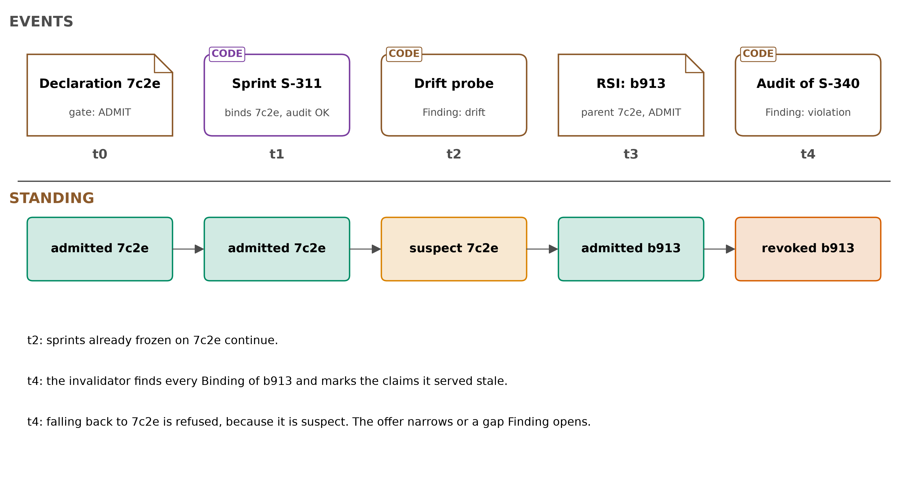
Figure 14. research.retrieval over time: admitted, bound, drifted, revised, revoked.

10. Capabilities today, and why CC is better
This chapter shows what capabilities look like today in jiuwenswarm and in AI4Research, compares AI4Research's capsules with the schema record by record, and ends with why CC is better for both. Two real examples are in §2f.
The pattern across all of it is not that the ideas are missing. Every layer names them and leaves them unenforced: agent-core's ToolCard carries parallel_safe, stateless and idempotent, written by the author and defaulting to safe when absent (core/foundation/tool/base.py:92, :241); jiuwenswarm classifies each tool call by side effects and risk tier, derives those facts from tool names, and ships the boundary disabled (rails/permissions/tool_capabilities.py:39-49, auto_config.py:99-103, resources/config.yaml:1130); AI4Research declares 95 preconditions its planner's filter never reads; Symphony counts a route as verified after one successful run. So CC asks for no new idea. It asks that the same facts be declared once, in one place, and read by code before a capability is used.

10.1 jiuwenswarm skills today
Counted in jiuwenswarm 02b37f47f, over the 34 bundled skills in resources/agent/workspace/skills/ (merged/DERIVATION.md D1-D4, D11):
 | Today | Source
What a skill declares | 33 of 34 declare a name and description; 7 a version; 3 allowed_tools; 1 models; none declares inputs, outputs, preconditions or effects; 1 has invalid YAML | D1
What it really does | 25 of 34 ship scripts; 13 state their prerequisites only in prose; 29 describe their outputs only in prose | D2
Tool limits | allowed_tools is not enforced: agent-core's skill loader reads only the description (skill_use_rail.py:946-958), and skills get bash by default (:77, :94). advanced-daily-report writes files and pushes reports to Feishu, none of it declared | D4
Identity and versions | installed by plain copy, with no hash; an experience layer changes a skill's behaviour without a new version, and a teammate's experience is saved without review (config.yaml:732-733) | Landscape; D11
Groups | SkillPacks list members by name and are disabled together when one member is disabled (skillpack.py:180-258); Swarm Skills list dependencies by name in dependencies.yaml, each with required and a purpose of up to 150 characters, which the agent checks itself at start-up (docs/en/SwarmSkills.md:339-372) | source
Permissions | off in the shipped configuration, so every tool call is allowed until a user turns them on | Swarm 05

10.2 AI4Research capsules today
Capsules are looked up by id alone: the version field, present in 43 of the 85 manifests, plays no part in the lookup (capability_capsules.py:449-451). Bundled jiuwenswarm skills, for comparison, go through no admission at all.
This section is the reason the schema looks the way it does. AI4Research already has capability capsules: 80 in its registry (74 stable, 6 draft), with 85 manifests in harness/config/capability-capsules/ and harness/capability-capsules/ (AI4Research b0bf165f9). The schema is not a new idea laid over nothing. It takes each part of today's manifest and changes how strictly it is held. For each record: what today's capsules declare, what code actually does with it, what the schema requires instead, and the evidence for the change.

What AI4Research's capsules enforce
Today's capsules are strict on shape and lenient on meaning. Every field must be present, but little is evaluated, and what is evaluated is a mix of four hard-coded checks, file presence, and a model reading prose.
Part of today's manifest | Example (cap.research-retrieval.yaml) | What code does with it
inputs and outputs | research_question: markdown; sources_jsonl: jsonl (file formats), and separately consumes: artifact.research_question | the planner's filter checks artifact types; nothing checks names against one vocabulary
preconditions | task_type_in: [research, knowledge-extraction] (:40) | the validator only requires a non-empty list (capability_capsules.py:676-678). At dispatch, four kinds are evaluated against the task envelope; any other kind passes silently, because there is no else (:1220-1242). The filter never reads them
postconditions | output_present: sources_jsonl (58 uses in the 46 manifests of config/) | checked after the node, for file presence only (graph_node_dispatcher.py:8034)
invariants | "Every evidence row resolves to a source and a verified span in that source's extract" (:52-56) | a non-empty list is required. After the node, each becomes a semantic_review item: a model judges the prose (static_execution_compiler.py:560-566), with no measured error
applicability | positive_signals: [research, source, …] (:11) | a negative keyword excludes a capsule, and positive keywords score it (capability_capsules.py:1041-1052). Keywords decide eligibility today
effects | write: [artifacts.research], network: [web] (:67) | the filter excludes on effects in both directions (elastic_planner.py:4553-4648); no scope, no undo
dependencies | required_guard_capsules, mcp_capabilities, secret_refs | guard and resource capsules are pinned at the freeze; MCP providers are resolved live; a secret needs a guard (capability_capsules.py:684-690)
verification | named self_checks, prose pass_conditions, a preferred external verifier (:90) | names and prose; no runner hash; no record of who wrote the check
admission | status | only stable is admitted, but a missing status counts as stable (capability_admission.py:14); only the manifest file is hashed (execution_authority.py:40)

10.3 Each record, compared
Each row takes one record of today's capsules, says what AI4Research does with it now, what the schema does instead, whether that is stricter or looser, and why. Most rows are stricter: a field that is present but never evaluated becomes a field that code evaluates. A few are deliberately looser, where today's strictness blocks useful work without making anything safer.
Record | Today | This schema | Stricter or looser | Why (evidence)
Declaration: inputs, outputs | file-format types; artifact types separately | types from one versioned vocabulary; every output names the check that validates it | stricter | Contract2Tool's filter worked only once names were normalised to one vocabulary; Symphony lets unknown match any same-named input (§4)
Declaration: preconditions | four hard-coded kinds at dispatch (capability_capsules.py:1220-1242), reached only for capability-native envelopes (operator_runtime.py:796-808); unknown kinds pass; never in the filter | one code-evaluable predicate {path, operator, value} with state_source, max_age_s, on_unknown, on_unavailable and a parity check; the filter and dispatch run the same evaluator; an operator outside the vocabulary is rejected at admission; [] only with a stated reason | stricter, and more general | a gate is sound only when its predicate is the capability's exit logic, and fail-open or fail-closed must be explicit (Don't Offer); today's two predicate sets are exactly the parity gap. Forcing non-empty lists invited filler such as task_type_in
Declaration: invariants | prose, judged by a model after the node | each bound to a check with a runner and an author, or marked declared so the gap is visible | stricter | a judge nobody measured can fail silently (The Blind Curator); a declared permission is not an enforced one (RelAIBuild)
Declaration: effects | names per kind | a scope, an ext: or ws: resource, idempotent, the capability's effect_class, a reversibility (inverse, scoped, compensate, emission) and an assurance per effect | stricter | reversal holds only inside a boundary (Cordis); composition screening needs the modifies set (SkillFuzz)
Declaration: applicability | task types in all 85 manifests, plus positive and negative keywords | both dropped from the capsule. The task type lives on the Plan step; input limits are needs.when predicates over inputs | moved to the demand side | a capsule holds no task (invariant 12), so it is reused wherever its ports fit; a keyword top-5 filter cut success from 0.775 to 0.620 (Contract2Tool); invariant 8 bars heuristics from eligibility
Declaration: uses written in | requires_after names the capsule to run first in 42 of 85 manifests; named worker operators; a fixed workflow position in 14 names or descriptions | none: order comes from data (ports) or the plan's depends_on; the worker is the workflow's choice; summary may not name stages or workflows | stricter | a plan fact written into the supply fixes the plan's order inside the capsule, where the builder, not the planner, writes it (invariant 9)
Declaration: dependencies | guard and resource capsules pinned; MCP providers live; no purpose recorded | every dependency pinned by hash or version by default, or unpinned if the author writes down its purpose and contracts, at a cost to trust (§3) | stricter by default, flexible by declaration | dependencies rot; given the failed contract, one-round repair rose from 10% to 78% (Skill Drift Is Contract Violation). jiuwenswarm's Swarm Skills already write a purpose per dependency; CC ties it to unpinning and to repair (design, §6)
Declaration: identity | only the manifest file hashed | every body file hashed; overlays hashed | stricter | a body can change under an unchanged manifest; jiuwenswarm changes skills with no new version (§2e)
Verdict | status, defaulting to stable | a typed outcome (ADMIT, REJECT, DEFER, ESCALATE) with reasons; each check with its runner hash and author; judge error measured; parity results; RSI's own result as builder_gate evidence | stricter, with one looser path | 215 of 222 self-built tools failed held-out tests of their own job; a DGM node gamed its checker's signal. Looser: a capsule can be admitted provisional on one postcondition, but only runs where its output is checked downstream, so imports are usable before suites exist (§3)
Standing | none: availability is the status field | one moving pointer per name, with typed reasons and history | new | retirement by evidence and eviction by cap must be told apart, or a dead curator looks alive; revert needs a target
Plan step | step ids; Symphony edges proposed by a model at confidence 0.7 or more; no fan-out, a many output is one run writing a directory | declared ports; typed unmet outcomes; the task type; optional fan-out (over), derived steps, restrict_to | stricter, and more general | typed edges repair locally (GraSP); guessed edges are an observation; one capsule mapped over items is real multiplicity
Binding | plan, capsule ids and approved fallbacks frozen (elastic_planner.py:5886-5888), but no runtime file reads the fallbacks; attempts overwrite a mutable state file, keeping the last 20 | bound[] with roles (primary, context, dependency), exact hashes, pinned overlays, fallbacks with their own Verdicts, evaluator version; an invocation per run (item, attempt, fallback), with predicate values on fresh state; the live hash must equal the pin | stricter; fallbacks usable | claims must trace to the exact run; a sprint sees only what it started with (invariant 3)
The library as a whole | a version on each registry entry, but lookups and the freeze resolve by bare id, so a change during planning aborts the freeze; a step nothing fits fails the plan (apo_plan_compiler.py:626) | versioned, append-only, monotone; three clocks; a generalist completes the step and records the gap | stricter, and able to improve itself | the 2026-09-15 report, R1-R2 and its §4.5; AllocBench for building on recurrence
Finding | none | screening, audits, drift probes and use, which can withdraw standing and never grant it | new | composition harm lives in sets, not single capsules (SkillFuzz); observation keeps a role, subordinate to declaration (§1)

10.4 The choice, in one line
The schema keeps today's instinct, which is to declare everything and validate that it is present. It then makes each declaration evaluable (code, not prose), owned (a named writer and author), and pinned (by hash). Where it loosens anything, the loosening is confined:
- provisional capsules and generalists run on judged steps too, with their claims labelled rather than refused;
- unpinned dependencies cost trust and require a written purpose;
- the keyword signals it drops are a heuristic the evidence shows costs accuracy.

10.5 Why CC is better, for openJiuwen and for AI4Research
Each row is a gap that exists today, what CC does about it, and the measured reason the gap matters. The evidence is from each paper's own setting; none of it measures CC as a whole, which M2 begins to do against today's filter.
Gap today | What CC does | Why it matters
nothing code can filter on: jiuwenswarm skills declare no inputs, outputs, preconditions or effects, and AI4Research's filter never reads preconditions | declared ports and preconditions; code removes what cannot apply before a model chooses | without such a gate, a model picked an unrunnable skill in 7.8% of 1,000 conversations (2608.01050 p5)
eligibility by keywords, or by a model reading every row | a filter on declared contracts | on a synthetic 100-tool registry: all tools 0.775 success at 26,172 tokens a task; a keyword top-5 filter 0.620 at 4,482; a filter on declared contracts 0.980 at 2,528 (2606.07904 Table V)
more capabilities to choose from | about ten seed capsules, growth only where gaps recur | the pass rate fell by 0.21 (95% CI 0.15 to 0.27) as a library grew to 202 skills (2605.24050)
nothing proves what ran: skills copied with no hash, AI4Research hashing only the manifest, experience layers changing behaviour with no new version | every file hashed; overlays pinned per sprint; the live hash must equal the pinned one | with pinned replay, untouched work stayed identical in 3 of 3 runs while loop agents regenerated it (2605.06365 Table 1; n = 3)
undeclared effects, unenforced tool limits, permissions off | declared effects compared with what is observed; a CC sprint turns permissions on | 30.4% of the top 2,500 ClawHub skills were flagged conditional (2603.21019 p12)
quality judged by a model nobody measured | every judge keeps a standing, calibrated by spot checks; its passes are labelled until then | a biased judge silently stopped retirement (2607.07436 Table 1)
a self-built capability passes its task, not its job | held-out tests from another author before certification | 215 of 222 self-built tools failed held-out tests of their own job (2604.00392 p1, p5)
unreviewed evolution paths (teammate experience, TTSE) | a new overlay is a provisional revision, pinned per sprint | an ungated skill pool peaked at 62% with 105 skills, then fell to 50% with 179; a pre-commit gate reached 72% with 37 (2608.05810 Table 1)
harm found late cannot be undone | step identities and claim links reach exactly the affected work | of a 12.3-point drop, rolling back the harmful skills recovered 1.7 (2608.05810 p7)
Why this matters most for AI4Research. A frozen plan chains steps, so one wrong capability spreads into every later step and into the delivered claims. Sprints run for days and often unattended, so a problem found afterwards has already done its damage. And the output is research claims, which must say what they rest on. CC catches what it can before a run, labels what it cannot yet check, and traces what it missed to exactly the claims it touched.

11. What the schema does not claim
- It does not claim that declared capsules are correct. It claims that what was checked is recorded, and that what was not checked is labelled.
- It does not claim safety in combination. Screening reduces composition risk. Nothing certifies a set.
- It does not undo emissions or external state. It only controls when they are allowed, and checks a declared compensation once. What a capability does behind its interface is its author's (invariant 13).
- It does not see a remote body change its behaviour behind an unchanged interface. It catches a changed interface at dispatch, and changed behaviour only by observation, so such effects are at most audited.
- It does not clean a poisoned context. It traces and marks stale the claims a revoked context capsule touched, and never reuses that context. Influence that leaves no claim cannot be traced.
- It does not fix degradation at scale on its own. Much of it is the agent using no skill at all, which a filter cannot fix (2605.24050 Table 2).
- It does not promise identical replays. A model behind an API changes; sprints are recoverable, not byte-identical.
- It does not promise task success. Passing the filter means no declared exit holds, not that the capsule will succeed or was the right choice.
- It does not make token budgets hard.
- It does not verify Cordis-style inverses unless a check exercises them.
- The design has not been measured as a whole.
  - The numbers cited are the papers' own, in their own narrow setups.
  - None of them tested this design.
  - The worked example's findings, hashes and error rates are illustrative.
- It does not claim that a model judge is trustworthy. It claims that every judge's standing is recorded, that a pass from an unmeasured judge is labelled rather than trusted, and that only a measured judge counts toward certification or retirement (design).
- It does not claim that labelled results are right. Softening lets more work run; the labels say how much of it is backed. A reader who ignores the labels gets today's trust level, not CC's.
- It does not settle ownership, the ceiling, or the default thresholds. The ceiling is proposed (SCHEMA §4.10). The recurrence threshold of 2, the overlap policy and the risk ceilings are all (design).
- It does not describe a system that exists. The capsule layer is a proposal. Only the code cited as "today" and the openJiuwen sources exist.

12. Which parts of CC come first, and which come later
Not all of the schema is needed at once. The parts below are ordered by when they start doing something: the early ones apply to a single step, the later ones only once there is a library, a judge or a builder to serve. The order is a proposal, not a plan anyone has agreed, and nothing in it is measured.
First, on one node and then a few:
- the schema as a published format, so it can be read and argued with;
- one node: a Declaration, its body hashed and checked before loading, one predicate evaluator shared by the filter and dispatch, one rail writing the Binding and its invocations, and claims carrying a status;
- then three chained nodes: outputs feeding inputs by declared port type, the dispatch re-check on fresh state, approval for irreversible effects, and a gap Finding whenever nothing fits.
Later, each when there is something for it to do:
When | What is added
about ten capsules, over several sprints | Standing with one librarian, versions, judge standing from spot checks, drift probes on unpinned dependencies
verification supplies judges | measured judges, certification with held-out suites
RSI starts building | the lineage tree, suites inherited by children, recurrence counted before a build, composition screening
the library is large (about a hundred) | ranking and retrieval inside the offer, caps per slot, overlap Findings, retirement by evidence
Until those arrive a capsule stays provisional, a judge stays unmeasured, and every claim says so, so none of them blocks a sprint.
Left open: how the filter with declared preconditions is compared with today's filter, what the run contract's defaults should be for research steps, and who owns the shared predicate evaluator.
Where the detail lives. The schema is merged/SCHEMA.md, why each part exists is merged/DERIVATION.md, the knowledge base the documents are built from is kb/, and the directives are in the tundle obby vault.

Appendix A. The openJiuwen and AI4Research parts CC uses
CC is built onto what already exists. This appendix says what each part is and does, where it lives, and how CC uses it. Paths are in agent-core e23806c1 (under openjiuwen/), jiuwenswarm 02b37f47f and AI4Research b0bf165f9 (under harness/), each read in source. The fuller notes are in the tundle obby vault (openJiuwen Landscape, agent-core/Core 00-06, jiuwenswarm/Swarm 00-05).

A.1 agent-core: identity, loading and running
Part | What it is and does | Where | How CC uses it
Card and Config | a Card (ToolCard, AgentCard, WorkflowCard) is a capability's static, serialisable identity; a Config holds its runtime resources. agent-core's own rule forbids putting a session id or runner in a Card | .claude/rules/architecture.md:31; core/foundation/tool/base.py:78 | the Declaration is card-like: identity and contract, never a use
ToolCard flags | exposure, parallel_safe, stateless, idempotent on each tool | core/foundation/tool/base.py:78-110 | computed by CC's gate from declared effects, never trusted as written
AbilityManager, Runner.resource_mgr | registers tools, workflows, agents and MCP servers, which agent-core calls abilities, as process-wide state | core/single_agent/ability_manager.py:142; core/runner/runner.py | the path through which admitted capsules are registered
Runner | executes agents and workflows on one engine, with sessions, streaming and checkpoints | core/runner/runner.py | runs each capsule; unchanged

A.2 agent-core: the DeepAgent harness
Part | What it is and does | Where | How CC uses it
DeepAgent | the coding-agent framework built on the core: model calls, tools, subagents, a task loop, a workspace | harness/ | the agent that runs research steps
Rails | lifecycle hooks (before and after a model call or tool call, and more) through which features plug in without forking the loop | harness/rails/ | CC adds one rail, to record runs durably and compare tool calls with declared effects
Extension specs | SkillSpec, McpServerSpec, AgentTemplateSpec, PluginSpec: how each kind of extension is described for loading | harness/schema/extension_spec.py | the carriers a Declaration names
Extension binder | loads and unloads extensions at run time (apply_extension_hot), undoing registrations in reverse order; loads by name with no hash check | harness/extension_binder.py:27 | loads capsules from CC's hashed store, after CC checks the hash
SkillUseRail | offers skills to an agent through an allow-list (enabled_skills); the agent sees each skill's description and loads it when it chooses; it never reads a skill's allowed_tools | harness/rails/skills/skill_use_rail.py:52, :946-958 | applies CC's offer for skills
Permission engine | decides per tool call whether it is allowed, asked about, or denied (ALLOW, ASK, DENY); PermissionInterruptRail raises the question to a person. Off by default in jiuwenswarm | harness/security/permission_engine/core.py:140 | an irreversible, severe effect is an ASK, and a DENY on unattended runs
Verification subagent | a built-in subagent that reviews another agent's work with a model | harness/subagents/verification_agent.py:274, :318 | one of the judges CC gives a standing to
LoadRecord | the in-memory record of what an agent loaded | harness/resources/extension_resolver.py:60 | what CC's rail persists into Bindings

A.3 agent-core: protocols, teams, sessions and storage
Part | What it is and does | Where | How CC uses it
Harness protocol | a provider-neutral interface for hosting any agent harness. Vocabulary Session > Turn > Step. A Turn has exactly one start and one terminal event and may pause and resume; each tool call is an item; a TurnResult carries usage and cost | harness_protocol/events.py:23-31, :148, :178; results.py:149 | one capsule run is a Turn, or an item for a tool; cost comes from TurnResult
Harness providers | ready implementations of that protocol: native (DeepAgent), native_v2, claudecode, codex, dsh, built with create_harness(manifest, provider=...) | harness_providers/factory.py:160 | each generalist is an agent template naming a provider, such as Codex or Claude Code
HarnessCard | a harness's identity, protocol version and the host capabilities it requires | harness_protocol/models.py:132 | enrolment checks those requirements
Agent Teams | a Leader and Teammates over a message bus and task database; a Teammate may be an external Claude or Codex CLI (external_cli) | agent_teams/ | not a capsule in v1, because the Leader plans
Session VCS | version control for an agent's context: commit, snapshot, rewind, fork | core/session/vcs/manager.py:104-185 | a context that held a revoked capsule is not reused: a new session, or a fork from before it loaded
Checkpointers | save state so a run can resume after an interrupt or crash | core/session/checkpointer/, extensions/checkpointer/ | not a record of what ran; CC does not rely on them for evidence
SysOperation sandboxes | where filesystem, shell and code actually execute, locally or in a sandbox isolated per system, session or custom scope (jiuwenbox is one) | core/sys_operation/config.py:93; extensions/sys_operation/ | admission runs a capsule here to observe its effects; {instance} scopes map to a session sandbox
Stores | pluggable database, key-value and vector stores | extensions/store/ (db, kv, vector) | where CC keeps its records, rather than a new database
A2A | client and server for agent-to-agent calls, with agent cards | extensions/a2a/ | carrier for remote agents; CC fingerprints the card

A.4 agent-core: evolution, RSI and Symphony
Part | What it is and does | Where | How CC uses it
agent_evolving | training, evaluators, optimisers and the canonical OTLP Trajectory; skill experience is written through an EvolutionStore after preview and approval | agent_evolving/trajectory/model.py:132, store.py:23; checkpointing/evolution_store.py:41 | trajectories are consumed as they are; experience layers are pinned per sprint as overlays; its evaluators are judges with a standing
RSI | recursive self-improvement for agent harnesses; keeps a tree of attempts (RsiTreeNode: parent, adopted, score) and its own candidate gate | rsi/; rsi/schema.py:96-111 | builds capsules from gaps; its tree joins CC's by builder_ref; its gate is builder evidence, and CC's gate admits
Symphony | capability assets for skills, subagents and agents: fingerprints, a retrieval tree, an orchestration graph with Fast and Beam planners, experience and evaluation | symphony/ | downstream of CC: it indexes only what CC admits, through CapabilityProvider (interfaces/capability.py:13) and SkillGraphUpdater (interfaces/graph.py:14)

A.5 jiuwenswarm, the product
Part | What it is and does | Where | How CC uses it
Skills | SKILL.md folders; the 34 bundled skills declare a name and description and nothing about inputs, outputs or effects | resources/agent/workspace/skills/ | import sources, entering as provisional
SkillPacks, Swarm Skills | packs of skills listed by name; team skills with roles, a workflow and a dependencies.yaml whose entries carry a purpose | server/runtime/skill/skillpack.py; docs/en/SwarmSkills.md:339-372 | packs become composites pinned by hash; team skills are not capsules in v1
Swarmflow | deterministic multi-stage team workflows with parallel and pipeline operators (agent-core agent_teams/workflow) | docs/en/TUISwarmFlowGuide.md | one way the plan's fan-out could run
TTSE, teammate experience | evolution paths that keep facts and experience without review | resources/config.yaml:732-733 | pinned per sprint as overlays, or not loaded
Auto Permission | classifies each tool call: a ToolCapability with category, operation family, resource class, static_side_effects and risk_tier, plus the call's read, write and external paths; medium risk routes to a reviewer, and decisions go to an append-only hashed audit. The facts are derived from tool names (host_static, name_classification_hint, unknown), and permissions.enabled is false by default | agents/harness/common/rails/permissions/tool_capabilities.py:39-49, auto_decision.py:499-501, reviewer_route.py:230, persistent_audit.py, resources/config.yaml:1129-1132 | the nearest existing thing to declared effects: CC declares the same facts per capability, so they can be checked before selection rather than at the moment of the call
Eternal Conversation | an opt-in, hash-chained, append-only history of a session's tool calls and results | agents/harness/common/rails/eternal_conversation/ | a durable record CC can read where a session opts in

A.6 AI4Research, the workflow CC extends
Part | What it does today | Where | What CC changes
Planner | a model writes the plan (PlanIR) and may not name a capsule; a node no capsule can implement goes back for repair | lib/elastic_planner.py:1328-1329, :4137-4146 | nothing: plan steps state needs, never capsules
Hard filter | removes capsules by types, effects in both directions, network, proof classes, trust and admission status; never reads preconditions | lib/elastic_planner.py:4553-4648; lib/capability_admission.py:12-26 | adds declared preconditions, model limits, Standing and composition
Selection call | one model call reads the full rows of every node's eligible capsules and binds each node | lib/elastic_planner.py:4678-4760 | the model reads only a summary and ports per node
Freeze | pins each node's capsule by manifest hash; aborts if a definition changed | lib/execution_authority.py:28-94 | pins every body file and the Verdict, by snapshot
Scheduler | ready nodes in order, up to 8 in parallel, conflicting write scopes held back, one lease per operator | lib/graph_scheduler.py:2179-2215, :3203; lib/operator_runtime.py:504-515 | unchanged; CC supplies declared constraints
Dispatch | resolves the capsule and checks four precondition kinds | lib/operator_runtime.py:796-808; lib/capability_capsules.py:1220-1242 | the same predicates as the filter, on fresh state, and a hash check
Evaluation plan | compiles each node's gate from requirement checks, checks by type and the manifest's own claims | lib/evaluation_plan.py:277-356 | three parts with named writers; judges get a standing

Appendix B. Figures from the papers
Each figure is cropped from the paper's own PDF by ../deck/figures/extract_paper_figs.py, with its page and caveat.
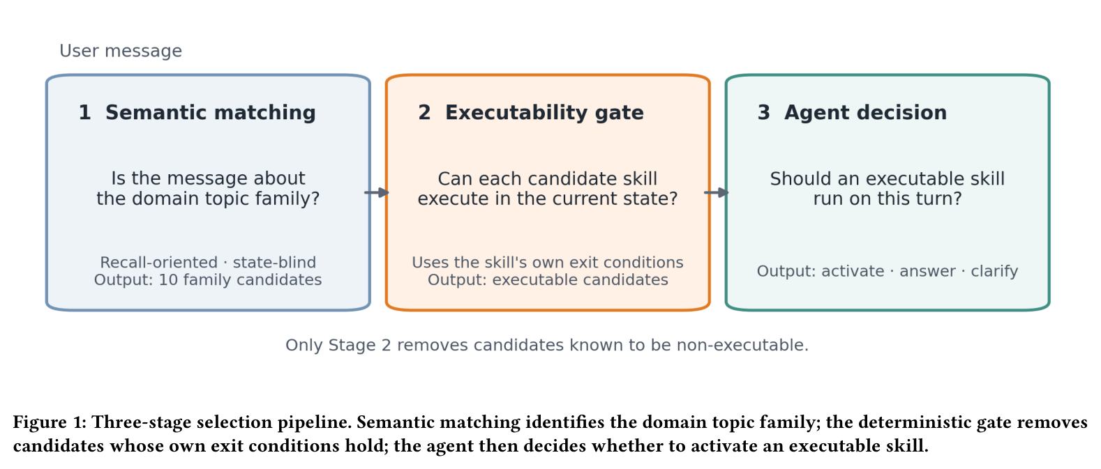
Figure 15. Don't Offer What Can't Be Done (2608.01050), Fig. 1, p4: the three-stage pipeline. Only stage 2, a deterministic gate on each skill's own exit conditions, removes candidates.
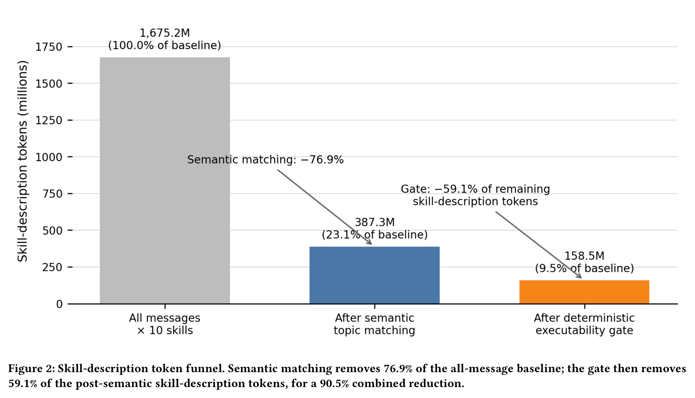
Figure 16. Don't Offer What Can't Be Done (2608.01050), Fig. 2, p4: skill-description tokens. The gate removes 59.1% after semantic matching, 90.5% combined. Ten skills, one month; description tokens only.
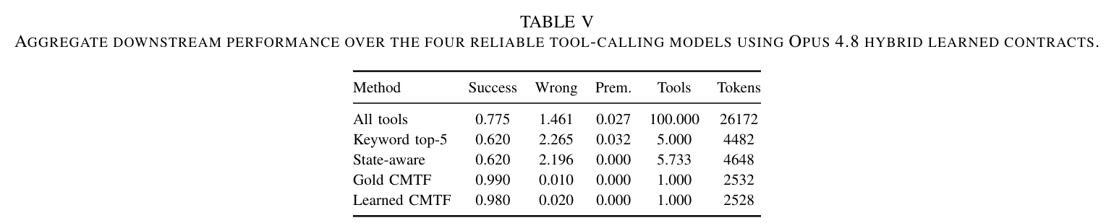
Figure 17. Contract2Tool (2606.07904), Table V, p8: a keyword top-5 filter cuts tokens but lowers success; contract-based filtering exposes one tool, cuts tokens tenfold and raises success. Synthetic registry, mocked execution.
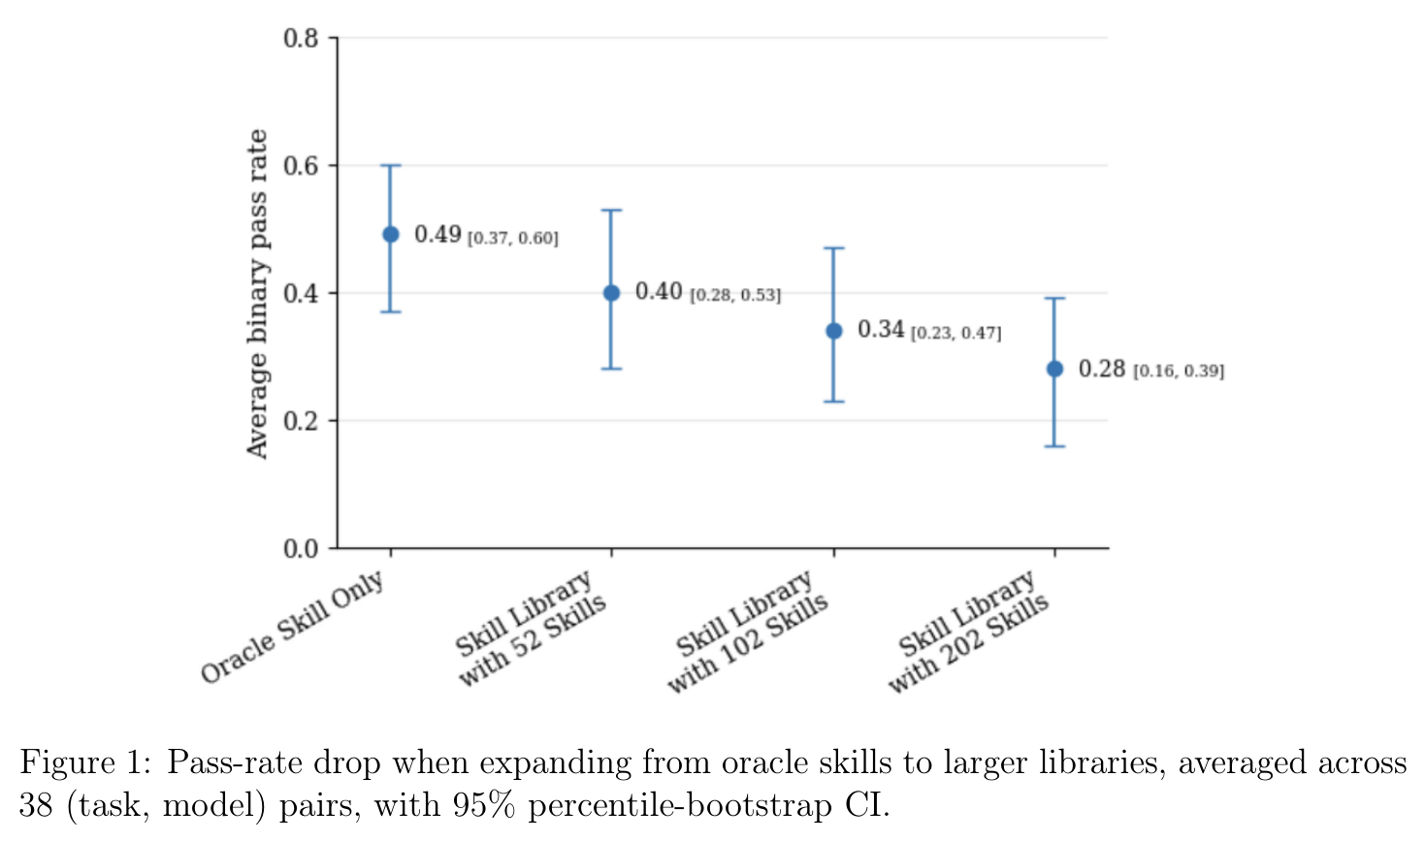
Figure 18. More Skills, Worse Agents? (2605.24050), Fig. 1, p3: pass rate falls as the library grows from the oracle skills to 202. Human-authored skills; 38 task-model pairs.
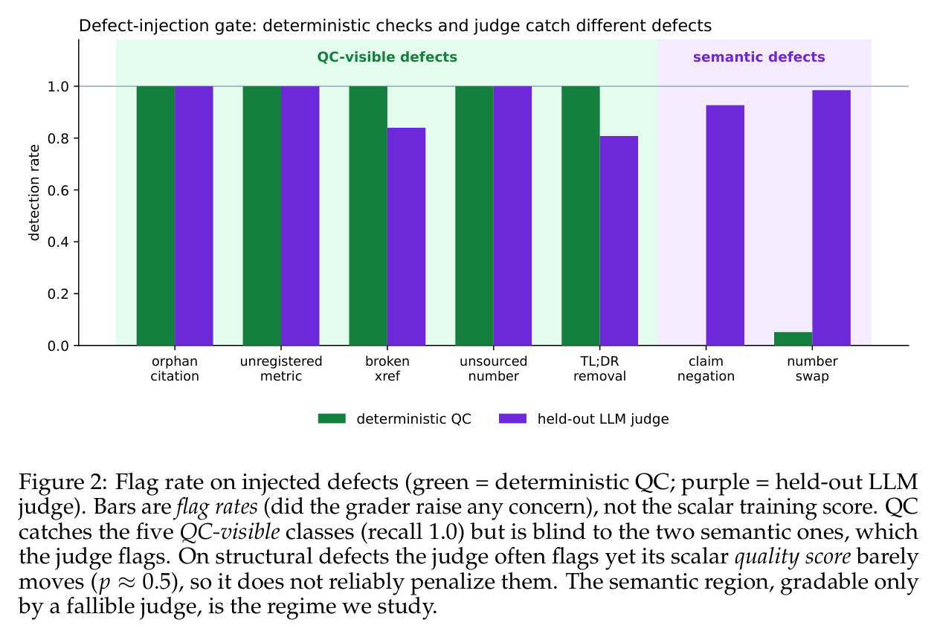
Figure 19. The Blind Curator (2607.07436), Fig. 2, p5: deterministic checks and an LLM judge catch different defects. One domain; flag rates, not scores.
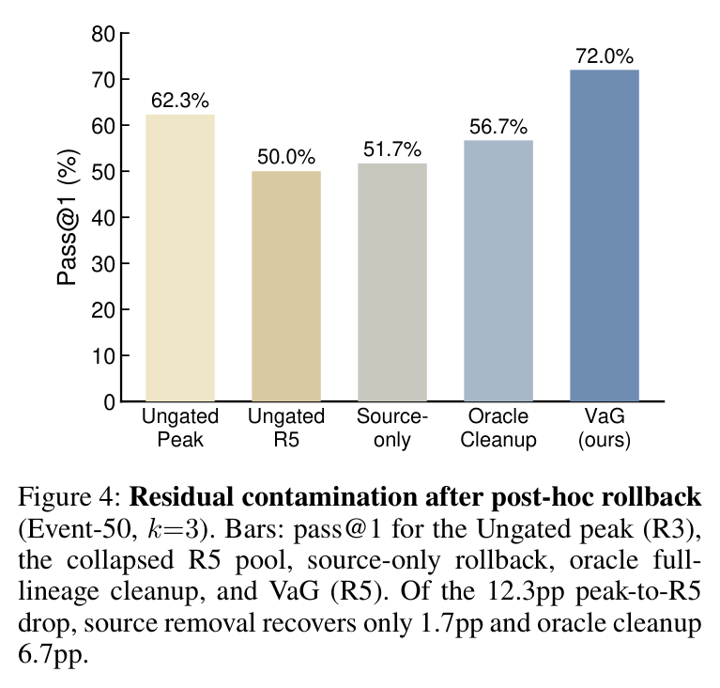
Figure 20. When Self-Evolution Backfires (2608.05810), Fig. 4, p7: rollback after the fact recovers little; removing the source skills recovers 1.7 of 12.3 points, and the pool gated before commit ends at 72.0%. One run.
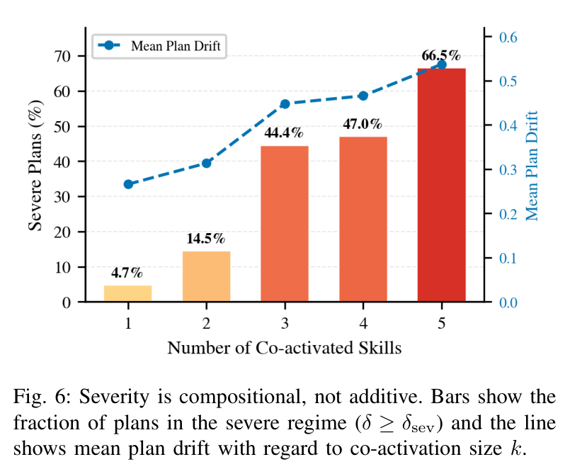
Figure 21. SkillFuzz (2607.02345), Fig. 6, p9: severe drift is rare for single skills and rises with the number co-activated, to 66.5% at five, which the paper calls a fourteen-fold increase.

